FY18 DATA COLLECTION AND REPORTING PROCESS
INSTRUCTIONS TO ACCESS AND MANAGE THE PIIRS FY18 FORMS

THE PIIRS FY18 COUNTRY PRESENCE & STAFF FORM 1
THE PIIRS FY18 REACH FORM 6
THE PIIRS FY18 IMPACT/OUTCOMES FORM 10

THE PIIRS FY18 COUNTRY PRESENCE & STAFF FORM

Please look at the three scenarios described here below and follow the instructions for the scenario that best works for you

SCENARIO 1 (best option, where possible) | SCENARIO 2 | SCENARIO 3
- My CARE office is using Office365 and we have CARE user accounts in Office365.  - We have good internet connectivity.  - We have Microsoft Excel 2016 in our computers.  IMPORTANT NOTE: If you don’t have Microsoft Excel 2016 available in your CARE office, please send us an email to piirs@careinternational.org and we will provide you with PIIRS forms that are compatible with other versions of Excel. | - My CARE office is NOT using Office365 and we don’t have CARE user accounts in Office365.  - We have sufficient internet connectivity to download the forms and also to upload them back once they are ready.  - We have Microsoft Excel 2016 in our computers.  IMPORTANT NOTE: If you don’t have Microsoft Excel 2016 available in your CARE office, please send us an email to piirs@careinternational.org and we will provide you with PIIRS forms that are compatible with other versions of Excel. | - My CARE office is not using Office365 and we don’t have CARE user accounts in Office365.  - We have limited internet connectivity, which means, we can download the forms but we would have challenges uploading them back once they are ready. We’ prefer to submit forms via email.  - We have Microsoft Excel 2016 in our computers.  IMPORTANT NOTE: If you don’t have Microsoft Excel 2016 available in your CARE office, please send us an email to piirs@careinternational.org and we will provide you with PIIRS forms that are compatible with other versions of Excel.
Instructions for Scenario 1 | Instructions for Scenario 2 | Instructions for Scenario 3
- Go to this link: https://careinternational.sharepoint.com/:f:/s/PIIRS/EkMqVRc7tQNLnC6Gi22utKIB7VaMu9FmqpZnsnIX30pHHQ?e=h9BBVA  - The link will take you to a SharePoint Folder containing subfolders for each CARE Country, with the FY18 COUNTRY PRESENCE & STAFF Form in each of them.  Important note: Please make sure you are signed into Office365 with your CARE account (upper-right corner).  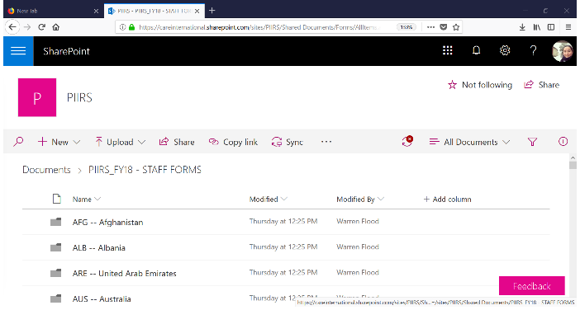  - Click on your Country folder and on the FY18 COUNTRY PRESENCE & STAFF Form you will be reporting on.  Once you do that, the form will automatically open in Excel Online (pic below). IMPORTANT: AT THIS POINT, THE FORM IS NOT READY TO BE FILLED IN YET and this may be why you may see a message of “Unsupported Features…”.  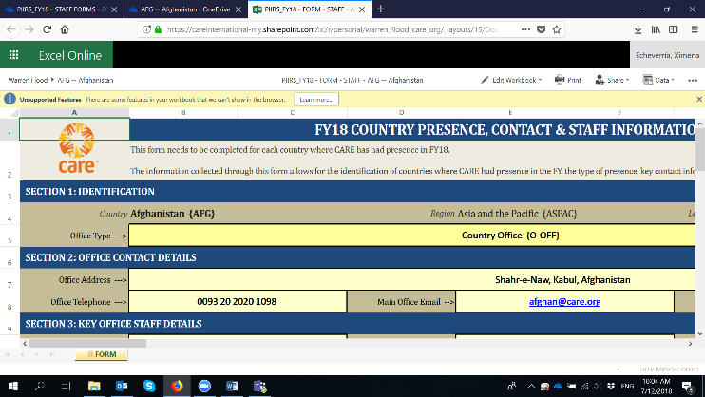  - On that same screen, go to “Edit Workbook” and select “Edit in Excel”. The form will then open directly in your computer.  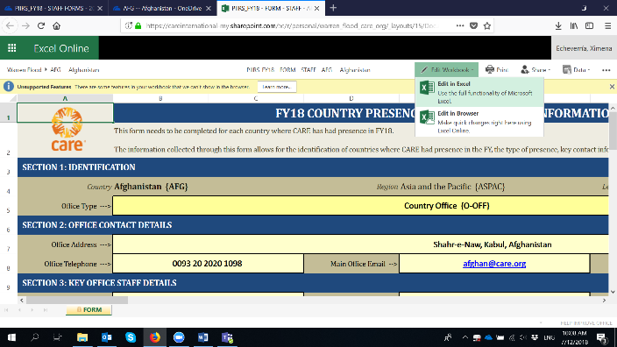  - Once the Form is open in Excel in your computer, please click on “Edit Workbook” and “Enable Content” so that the form is ready to be filled, with all its features working properly.  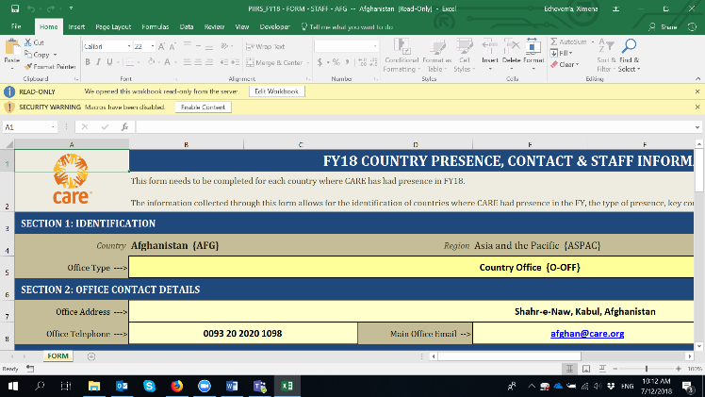  - And now you are ready to start entering data on the form!  Note that, because you are working on O365 directly, the form will remain in SharePoint at all times (it is not downloaded in your local computer). All changes you make will AutoSave directly in the original form that is in SharePoint. You can also click “Save” anytime, and it will still save all changes in SharePoint directly.  You can always download a copy of the form and save it in your computer but the form to be submitted to PIIRS will remain in SharePoint at all times.  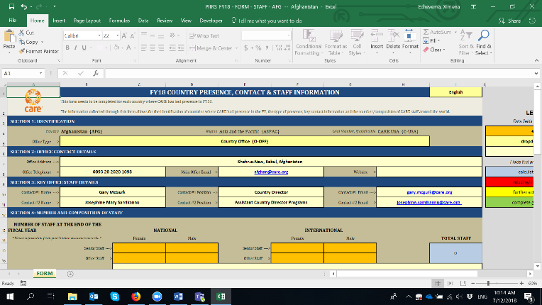  - If you want other colleagues to see/work on the form, you can always share the original link: https://careinternational.sharepoint.com/:f:/s/PIIRS/EkMqVRc7tQNLnC6Gi22utKIB7VaMu9FmqpZnsnIX30pHHQ?e=h9BBVA and point your colleagues to the form you want them to review/input data on.  - Once you have submitted the form, the PIIRS team will directly pull the information from it, and will get back to you if there are any questions on the data reported. | - Go to this link: https://careinternational.sharepoint.com/:f:/s/PIIRS/EkMqVRc7tQNLnC6Gi22utKIB7VaMu9FmqpZnsnIX30pHHQ?e=h9BBVA  - The link will take you to a SharePoint Folder containing subfolders for each CARE Country, with the FY18 COUNTRY PRESENCE & STAFF Form in each of them.  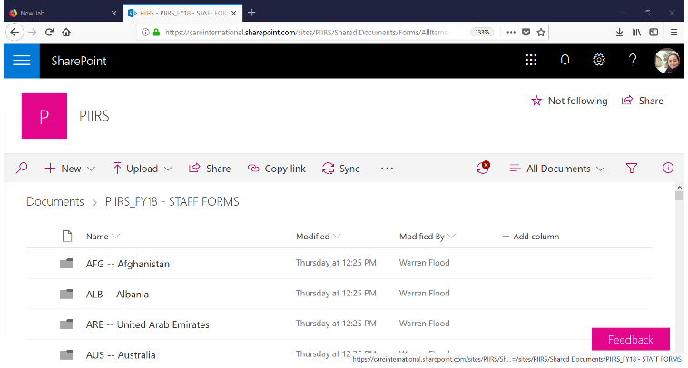  - Click on your Country folder and you will find the FY18 COUNTRY PRESENCE & STAFF Form in there. Click on "more" (the three vertical dots), select "Download" (see picture below) and download the form in your computer WITHOUT CHANGING THE NAME OF THE FILE  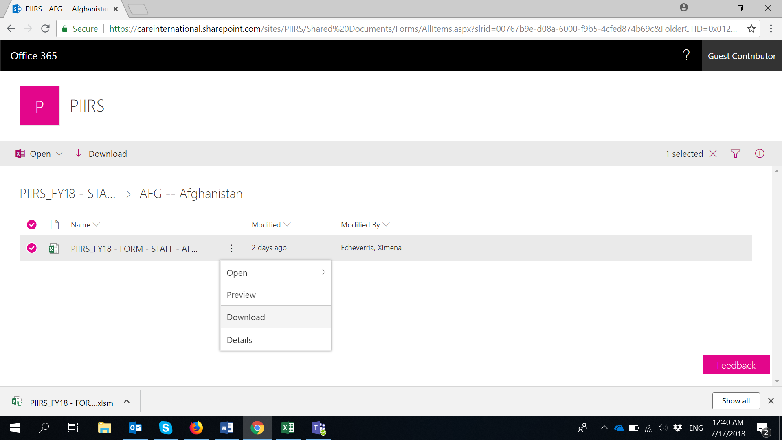  - Once you have downloaded the form to your computer, you can open it in Excel, and click on “Enable Editing” and “Enable Content” so that the form is ready with all its features working properly.  And now you are ready to start reporting data on the form!  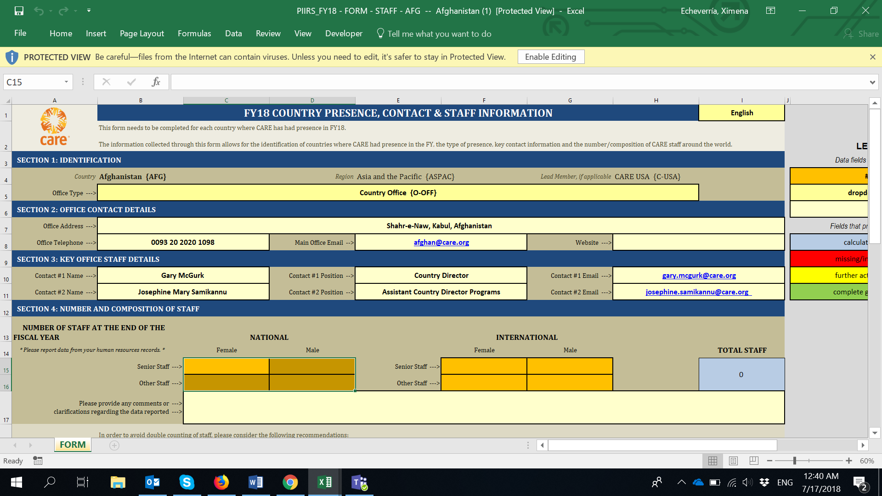  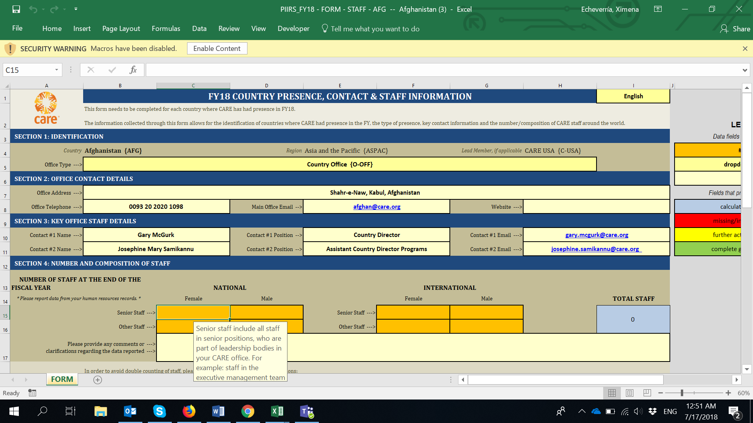  - Once you have finished filling in the form and you are ready to submit it, please go to your Country’s folder using the original link to SharePoint : https://careinternational.sharepoint.com/:f:/s/PIIRS/EkMqVRc7tQNLnC6Gi22utKIB7VaMu9FmqpZnsnIX30pHHQ?e=h9BBVA  Click on “Upload” then select “File” and upload the form you have finished filling, from your computer.  IMPORTANT: Once you do this, you will receive a message asking if you want to replace the original file (picture below). YES, you do! There is no problem with that. You will be replacing the original (empty) form in SharePoint with the one you have filled/completed.  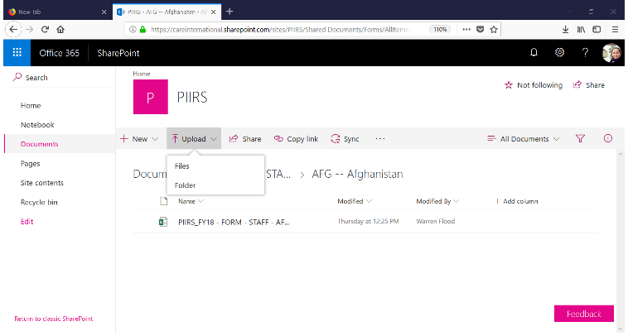  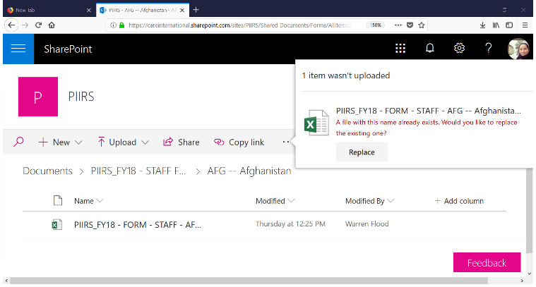  - Once you have submitted the form, the PIIRS team will directly pull the information from it, and will get back to you if there are any questions on the data reported. | - Go to this link: https://careinternational.sharepoint.com/:f:/s/PIIRS/EkMqVRc7tQNLnC6Gi22utKIB7VaMu9FmqpZnsnIX30pHHQ?e=h9BBVA  - The link will take you to a SharePoint Folder containing subfolders for each CARE Country, with the FY18 COUNTRY PRESENCE & STAFF Forms in each of them.  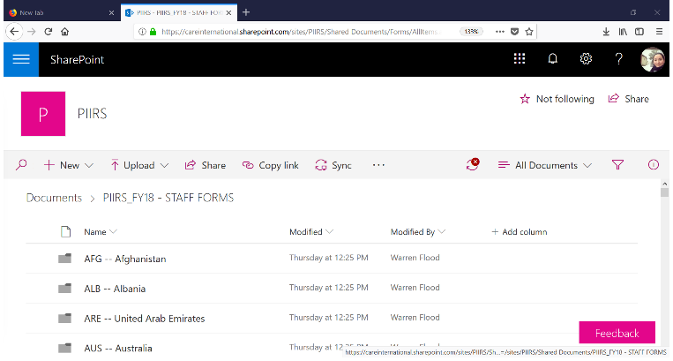  - Click on your Country folder and you will find the FY18 COUNTRY PRESENCE & STAFF Form in there. Click on "more" (the three vertical dots), select "Download" (see picture below) and download the form in your computer WITHOUT CHANGING THE NAME OF THE FILE  - Once you have downloaded the form to your computer, you can open it in Excel, and click on “Enable Editing” and “Enable Content” so that the form is ready with all its features working properly.  And now you are ready to start reporting data on the form!  - Once you have finished filling in the form and you are ready to submit it, please send it to piirs@careinternational.org  - Once you have submitted the form by email, the PIIRS team will pull the information from it, and will get back to you if there are any questions on the data reported.

THE PIIRS FY18 REACH FORM

Please look at the three scenarios described here below and follow the instructions for the scenario that best works for you

SCENARIO 1 (best option, where possible) | SCENARIO 2 | SCENARIO 3
- My CARE office is using Office365 and we have CARE user accounts in Office365.  - We have good internet connectivity.  - We have Microsoft Excel 2016 in our computers.  IMPORTANT NOTE: If you don’t have Microsoft Excel 2016 available in your CARE office, please send us an email to piirs@careinternational.org and we will provide you with PIIRS forms that are compatible with other versions of Excel. | - My CARE office is NOT using Office365 and we don’t have CARE user accounts in Office365.  - We have sufficient internet connectivity to download the forms and also to upload them back once they are ready.  - We have Microsoft Excel 2016 in our computers.  IMPORTANT NOTE: If you don’t have Microsoft Excel 2016 available in your CARE office, please send us an email to piirs@careinternational.org and we will provide you with PIIRS forms that are compatible with other versions of Excel. | - My CARE office is not using Office365 and we don’t have CARE user accounts in Office365.  - We have limited internet connectivity, which means, we can download the forms but we would have challenges uploading them back once they are ready. We’ prefer to submit forms via email.  - We have Microsoft Excel 2016 in our computers.  IMPORTANT NOTE: If you don’t have Microsoft Excel 2016 available in your CARE office, please send us an email to piirs@careinternational.org and we will provide you with PIIRS forms that are compatible with other versions of Excel.
Instructions for Scenario 1 | Instructions for Scenario 2 | Instructions for Scenario 3
- Go to this link: https://careinternational.sharepoint.com/:f:/s/PIIRS/Ei0jiwJXDZ5GsxHuEg_mI0MBK-DmuNi0T6dZcfOLyhIxMA?e=FUoR1Z  - The link will take you to a SharePoint Folder containing subfolders for each CARE Country, with a BLANK FY18 REACH Form in each of them.  Important note: Please make sure you are signed into Office365 with your CARE user account, in the upper-right corner.  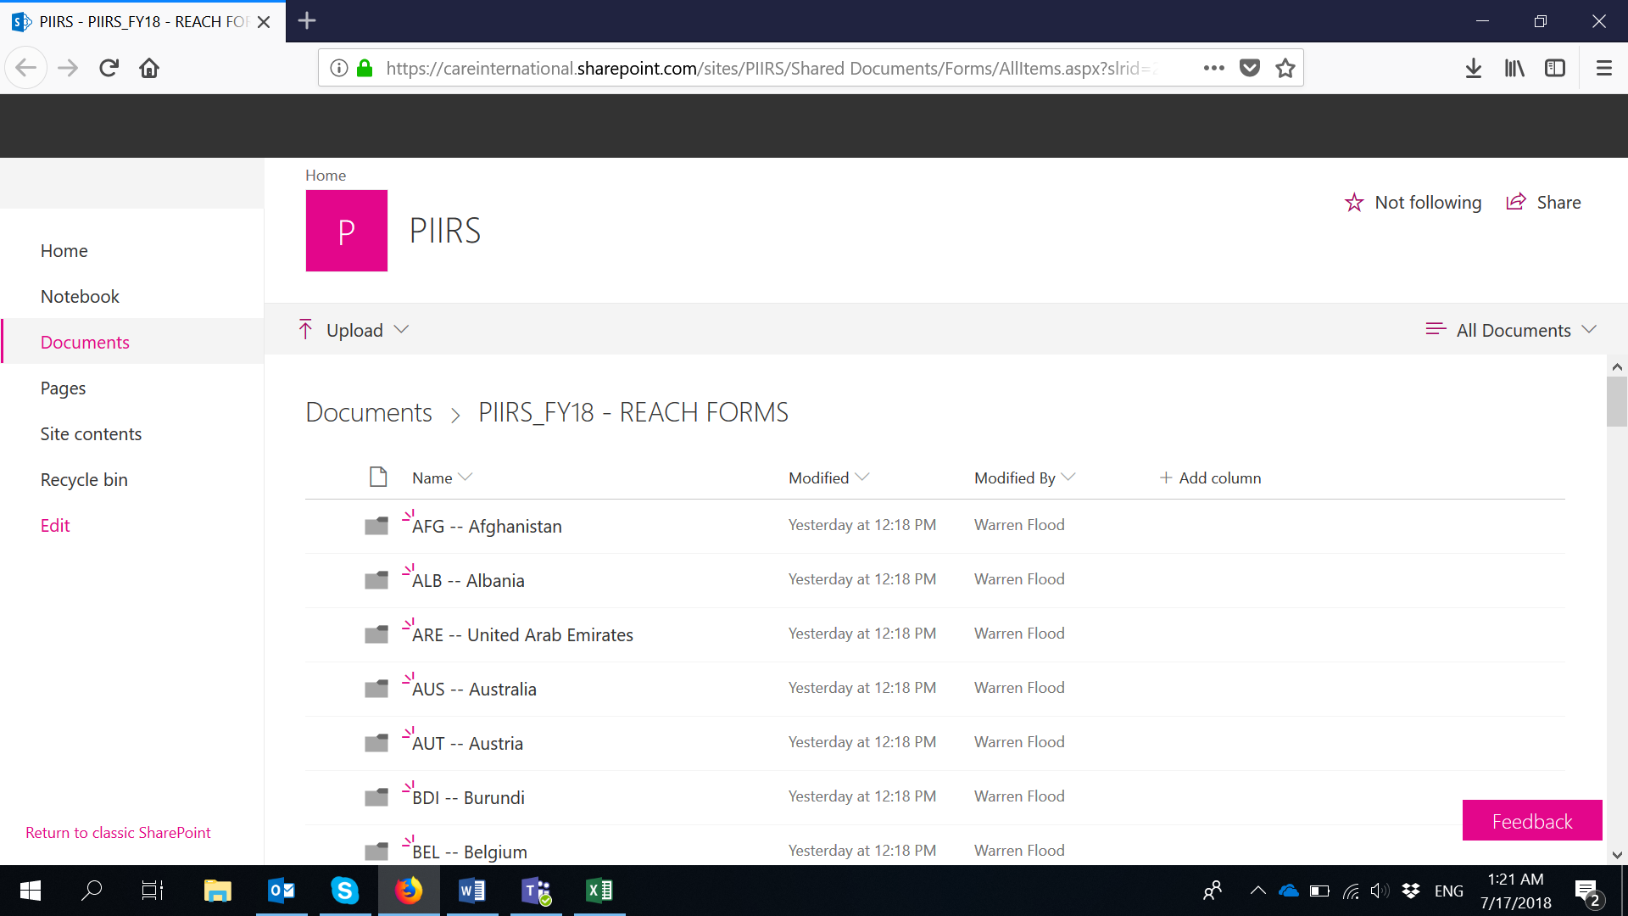  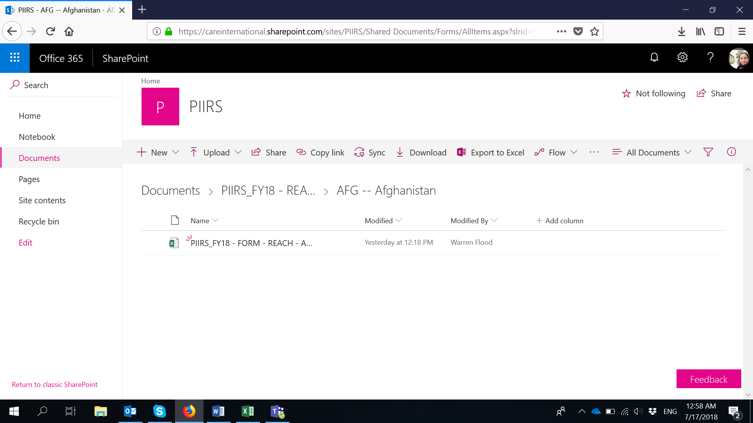  - click on the FY18 REACH form. Once you do that, the form will automatically open in Excel Online (pic below). IMPORTANT: AT THIS POINT, THE FORM IS NOT READY TO BE FILLED IN YET and this may be why you may see a message of “Unsupported Features…”.  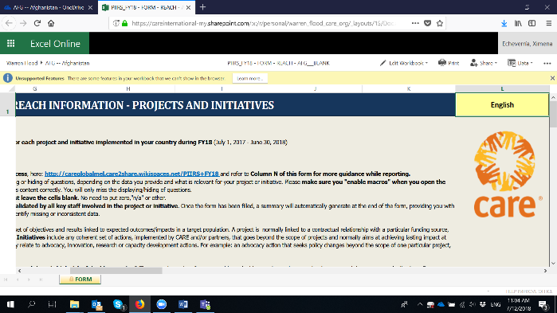  - On that same screen, click "Edit Workbook" and select "Edit in Excel".  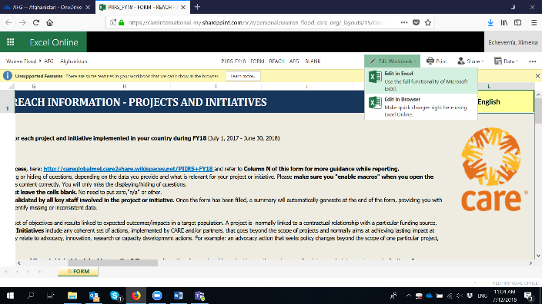  - Once the Form opens in Excel in your computer, please click on “Edit Workbook” and “Enable Content” so that the form is ready with all its features working.  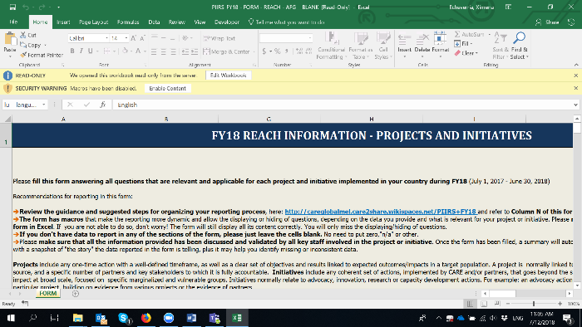  - Once you are there, with the form ready, please go to “Save as” and save as many copies of the REACH form as you require. That way, hoy have blank forms for all the projects/initiatives you will be reporting on. Note that when you click on “Save as”, the forms will be automatically save in your Country folder in SharePoint (not in your computer).  IMPORTANT: Please keep the original name of the file and just replace the BLANK word with any other that will identify the form with the right project/initiative. For instance:  PIIRS_FY18 - FORM - REACH - AFG___BLANK  PIIRS_FY18 - FORM - REACH - AFG___SHOUHARDOIII  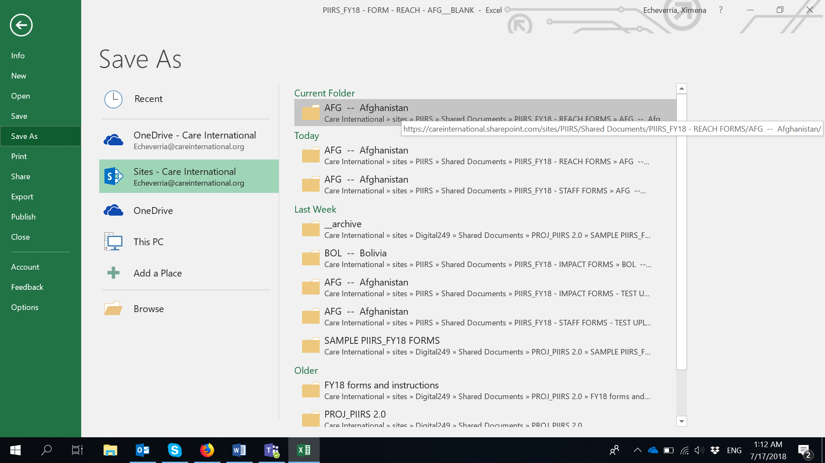  - Once you have made as many copies of the REACH forms as necessary, go to your Country folder in SharePoint and click on the specific FY18 REACH Form you will be reporting on: https://careinternational.sharepoint.com/:f:/s/PIIRS/Ei0jiwJXDZ5GsxHuEg_mI0MBK-DmuNi0T6dZcfOLyhIxMA?e=FUoR1Z  Once you do that, the form will automatically open in Excel Online (pic below). IMPORTANT: At this point, the form is not ready to be filled in yet. This is why you may see a message of “Unsupported Features…” popping up.  - On that same screen, click "Edit Workbook" and select "Edit in Excel".  - Once the Form opens in Excel in your computer, please click on “Edit Workbook” and “Enable Content” so that the form is ready with all its features working.  - And now you are ready to start reporting data on the form!  Note that, because you are working on O365 directly. The form will remain in SharePoint at all times (it is not downloaded in your local computer) and all changes you make will AutoSave directly in the original form that is in SharePoint . Also if you click “Save” anytime, it will still save all changes in SharePoint .  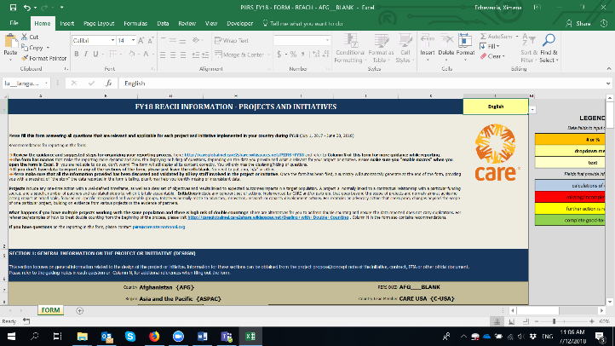  - If you want other colleagues to see/work on the form, you can always share the original link: https://careinternational.sharepoint.com/:f:/s/PIIRS/Ei0jiwJXDZ5GsxHuEg_mI0MBK-DmuNi0T6dZcfOLyhIxMA?e=FUoR1Z and point colleagues to your Country folder and the form you want them to review/input data on.  - If you want to share any other supporting documents that are related to the data reported in the form (e.g. marker vetting forms, evaluations documents, reports, etc.), please go to your Country’s folder using the original link to SharePoint : https://careinternational.sharepoint.com/:f:/s/PIIRS/Ei0jiwJXDZ5GsxHuEg_mI0MBK-DmuNi0T6dZcfOLyhIxMA?e=FUoR1Z  Click on “Upload file” and upload any supporting documents related to the data reported in the form.  - Once you have submitted the form and supporting documents, the PIIRS team will directly pull the information from it, and will get back to you if there are any questions on the data reported. | - Go to this link: https://careinternational.sharepoint.com/:f:/s/PIIRS/Ei0jiwJXDZ5GsxHuEg_mI0MBK-DmuNi0T6dZcfOLyhIxMA?e=FUoR1Z  - The link will take you to a SharePoint Folder containing subfolders for each CARE Country, with a BLANK FY18 REACH Form in each them.  - Click on your Country folder and click on the FY18 REACH form. Once you do that, the form will automatically open in Excel Online (pic below). IMPORTANT: AT THIS POINT, THE FORM IS NOT READY TO BE FILLED IN YET and this may be why you may see a message of “Unsupported Features…”.  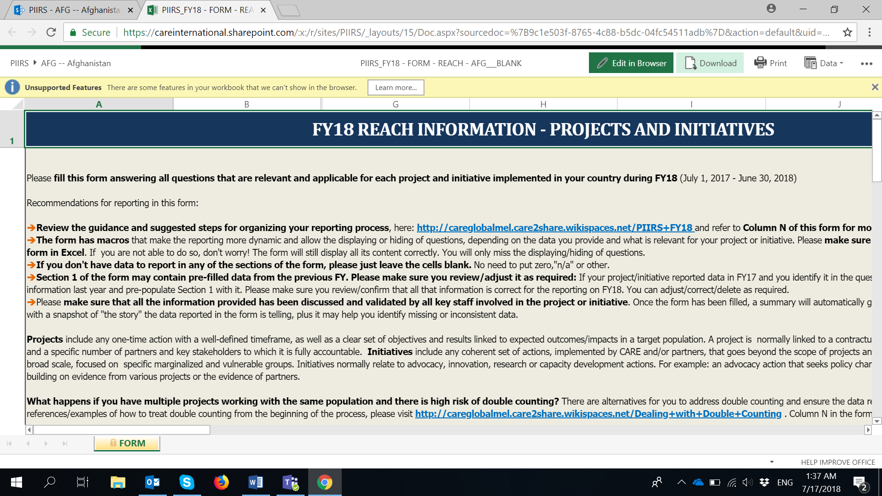  - On that same screen, click "Download" and “Yes”. Note that you may receive a message of “Features that we can't show in the browser and interactive reports will be removed from the downloaded copy.” Please ignore it and click on “Yes”.  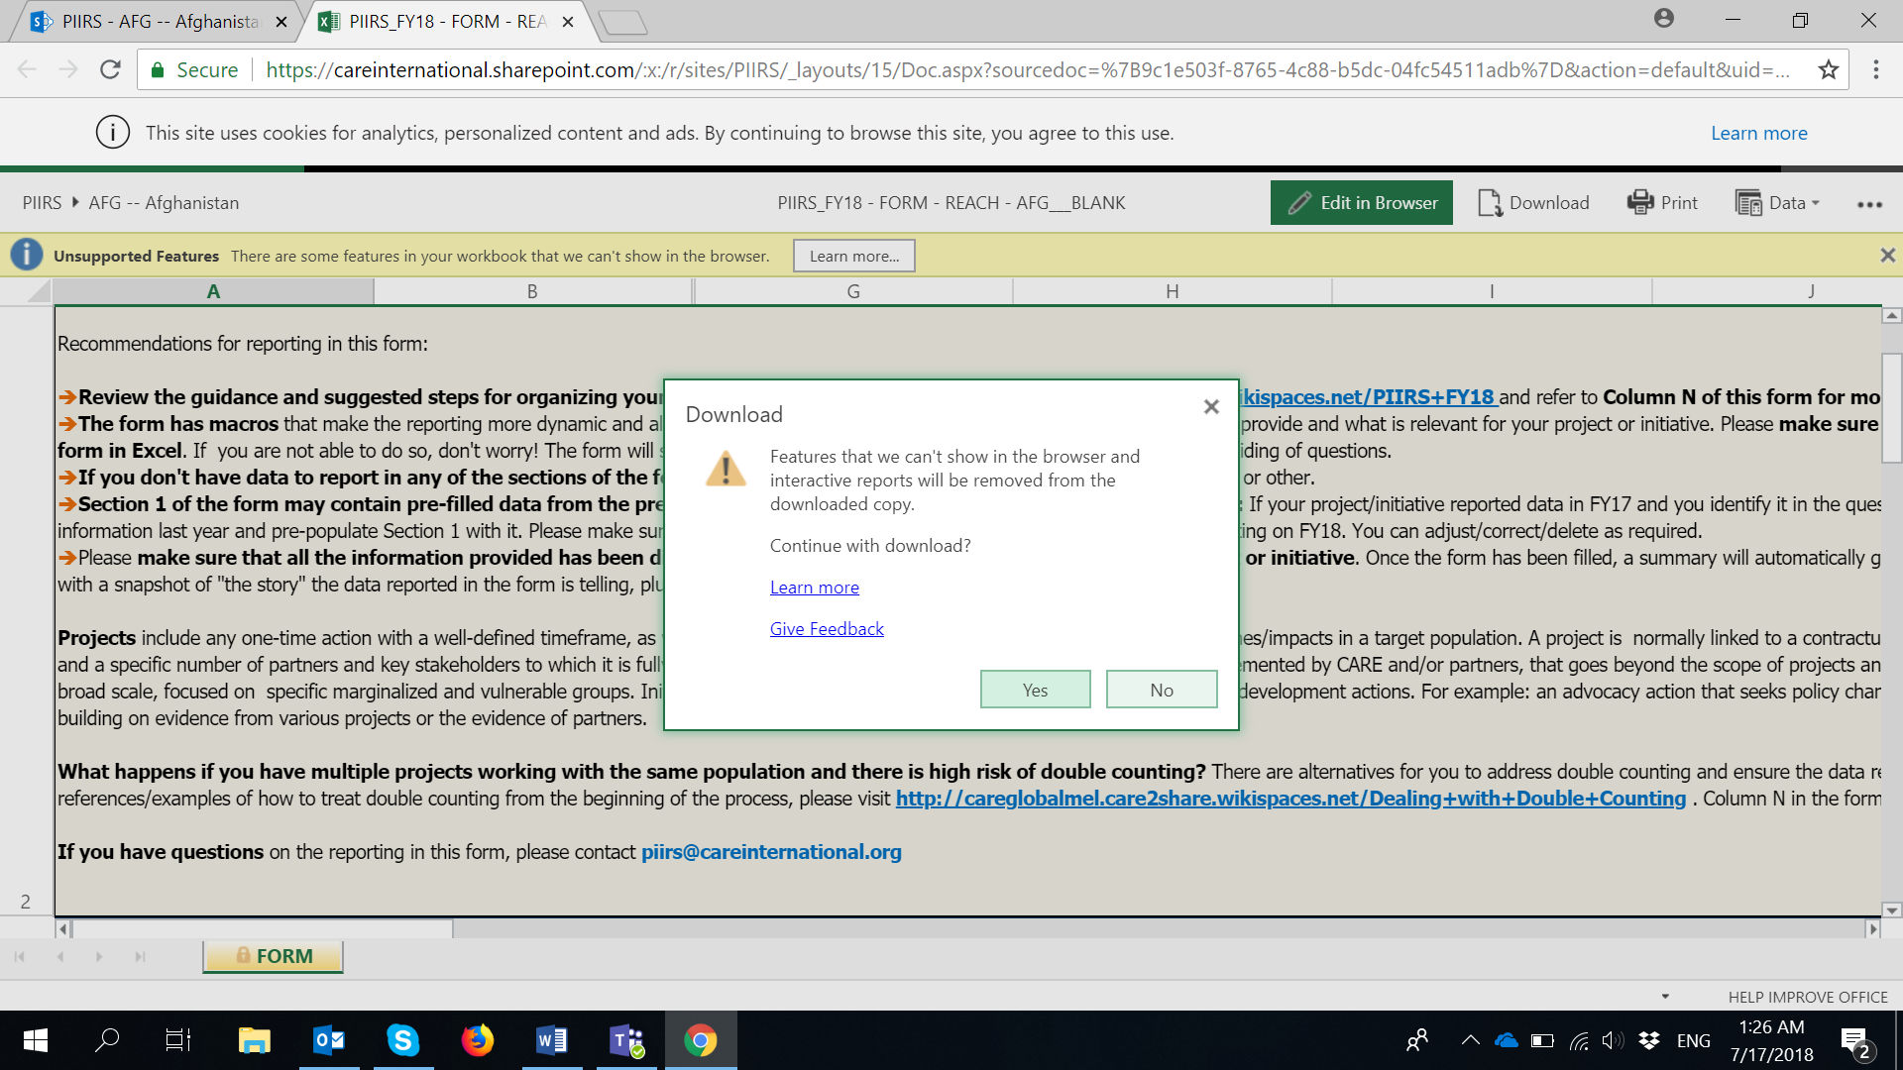  - Once you have downloaded the blank REACH form, you can open it in Excel in your computer, click on “Edit Workbook” and “Enable Content” so that the form is ready with all its features working.  - Once you are there, please use “SAVE AS” to save as many copies of the form as you require, in your computer.  IMPORTANT: Please keep the original name of the file and just replace the BLANK word with any other that will identify the form with the right project/initiative. For instance:  PIIRS_FY18 - FORM - REACH - AFG___BLANK  PIIRS_FY18 - FORM - REACH - AFG___SHOUHARDOIII  - Once you have saved the form(s) in your computer. You can start reporting on it/them normally.  - Once you have finished filling the form and you are ready to submit it, please go to your Country’s folder using the original link to SharePoint : https://careinternational.sharepoint.com/:f:/s/PIIRS/Ei0jiwJXDZ5GsxHuEg_mI0MBK-DmuNi0T6dZcfOLyhIxMA?e=FUoR1Z  Click on “Upload file” and upload the filled form you have in your computer. Once you have done so, you will be seeing multiple forms in your Country’s folder in One Drive.  IMPORTANT: Here you can also upload any other supporting documents that are related to the data reported in the form (e.g. marker vetting forms, evaluations documents, reports, etc.), following this same step.  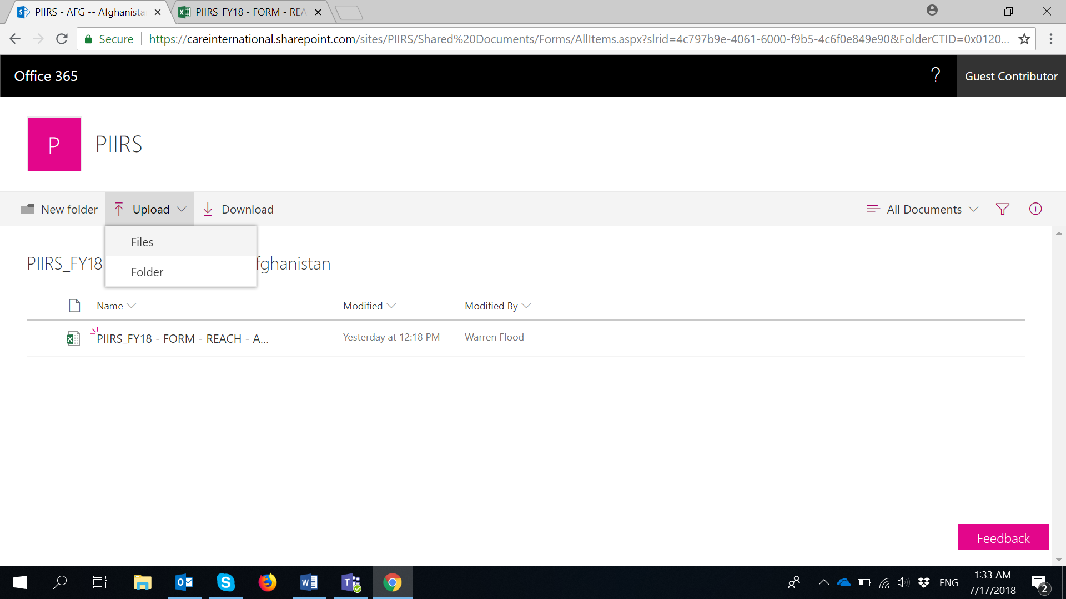  - Once you have submitted the form and supporting documents, the PIIRS team will directly pull the information from these, and will get back to you if there are any questions on the data reported. | - Go to this link: https://careinternational.sharepoint.com/:f:/s/PIIRS/Ei0jiwJXDZ5GsxHuEg_mI0MBK-DmuNi0T6dZcfOLyhIxMA?e=FUoR1Z  - The link will take you to a SharePoint Folder containing subfolders for each CARE Country, with a BLANK FY18 REACH Form in each them.  - Click on your Country folder and click on the FY18 REACH form. Once you do that, the form will automatically open in Excel Online (pic below). IMPORTANT: AT THIS POINT, THE FORM IS NOT READY TO BE FILLED IN YET and this may be why you may see a message of “Unsupported Features…”.  - On that same screen, click "Download" and “Yes”. Note that you may receive a message of “Features that we can't show in the browser and interactive reports will be removed from the downloaded copy.” Please ignore it and click on “Yes”.  - Once you have downloaded the blank REACH form, you can open it in Excel in your computer, click on “Edit Workbook” and “Enable Content” so that the form is ready with all its features working.  - Once you are there, please use “SAVE AS” to save as many copies of the form as you require, in your computer.  IMPORTANT: Please keep the original name of the file and just replace the BLANK word with any other that will identify the form with the right project/initiative. For instance:  PIIRS_FY18 - FORM - REACH - AFG___BLANK  PIIRS_FY18 - FORM - REACH - AFG___SHOUHARDOIII  - Once you have saved the form(s) in your computer. You can start reporting on it/them normally.  - Once you have finished filling the form and you are ready to submit it, please send the form(s) to piirs@careinternational.org  IMPORTANT: You can also send any other supporting documents that are related to the data reported in the form (e.g. marker vetting forms, evaluations documents, reports, etc.), following the same step.  - Once you have submitted the form and supporting documents by email, the PIIRS team will directly pull the information from these, and will get back to you if there are any questions on the data reported.

THE PIIRS FY18 IMPACT/OUTCOMES FORM

Please look at the three scenarios described here below and follow the instructions for the scenario that best works for you

SCENARIO 1 (best option, where possible) | SCENARIO 2 | SCENARIO 3
- My CARE office is using Office365 and we have CARE user accounts in Office365.  - We have good internet connectivity.  - We have Microsoft Excel 2016 in our computers.  IMPORTANT NOTE: If you don’t have Microsoft Excel 2016 available in your CARE office, please send us an email to piirs@careinternational.org and we will provide you with PIIRS forms that are compatible with other versions of Excel. | - My CARE office is NOT using Office365 and we don’t have CARE user accounts in Office365.  - We have sufficient internet connectivity to download the forms and also to upload them back once they are ready.  - We have Microsoft Excel 2016 in our computers.  IMPORTANT NOTE: If you don’t have Microsoft Excel 2016 available in your CARE office, please send us an email to piirs@careinternational.org and we will provide you with PIIRS forms that are compatible with other versions of Excel. | - My CARE office is not using Office365 and we don’t have CARE user accounts in Office365.  - We have limited internet connectivity, which means, we can download the forms but we would have challenges uploading them back once they are ready. We’ prefer to submit forms via email.  - We have Microsoft Excel 2016 in our computers.  IMPORTANT NOTE: If you don’t have Microsoft Excel 2016 available in your CARE office, please send us an email to piirs@careinternational.org and we will provide you with PIIRS forms that are compatible with other versions of Excel.
Instructions for Scenario 1 | Instructions for Scenario 2 | Instructions for Scenario 3
- Go to this link: https://careinternational.sharepoint.com/:f:/s/PIIRS/Eshg1-Cd8IVNgAo6mBctx7ABUPYMVwC0sGUvZqYVBeG8Dg?e=2JfD0z  - The link will take you to a SharePoint Folder containing subfolders for each CARE Country, with a BLANK FY18 IMPACT/OUTCOMES Form in each of them.  Important note: Please make sure you are signed into Office365 with your CARE user account, in the upper-right corner.  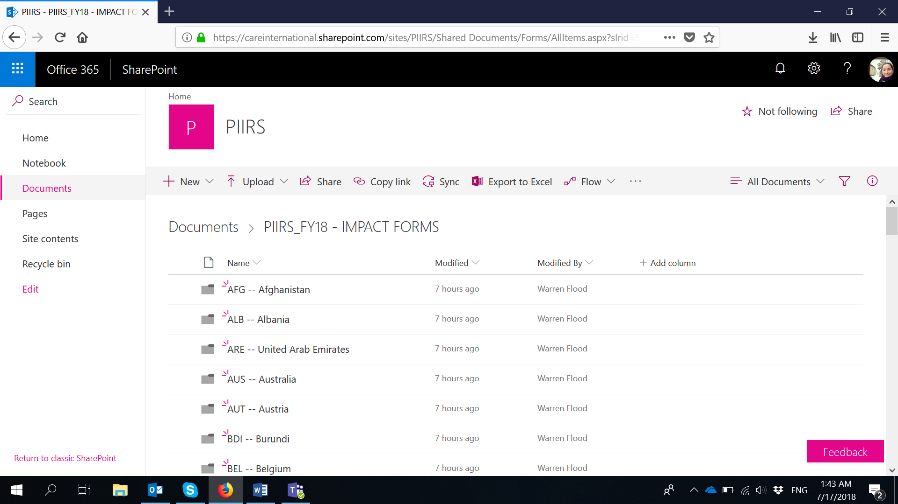  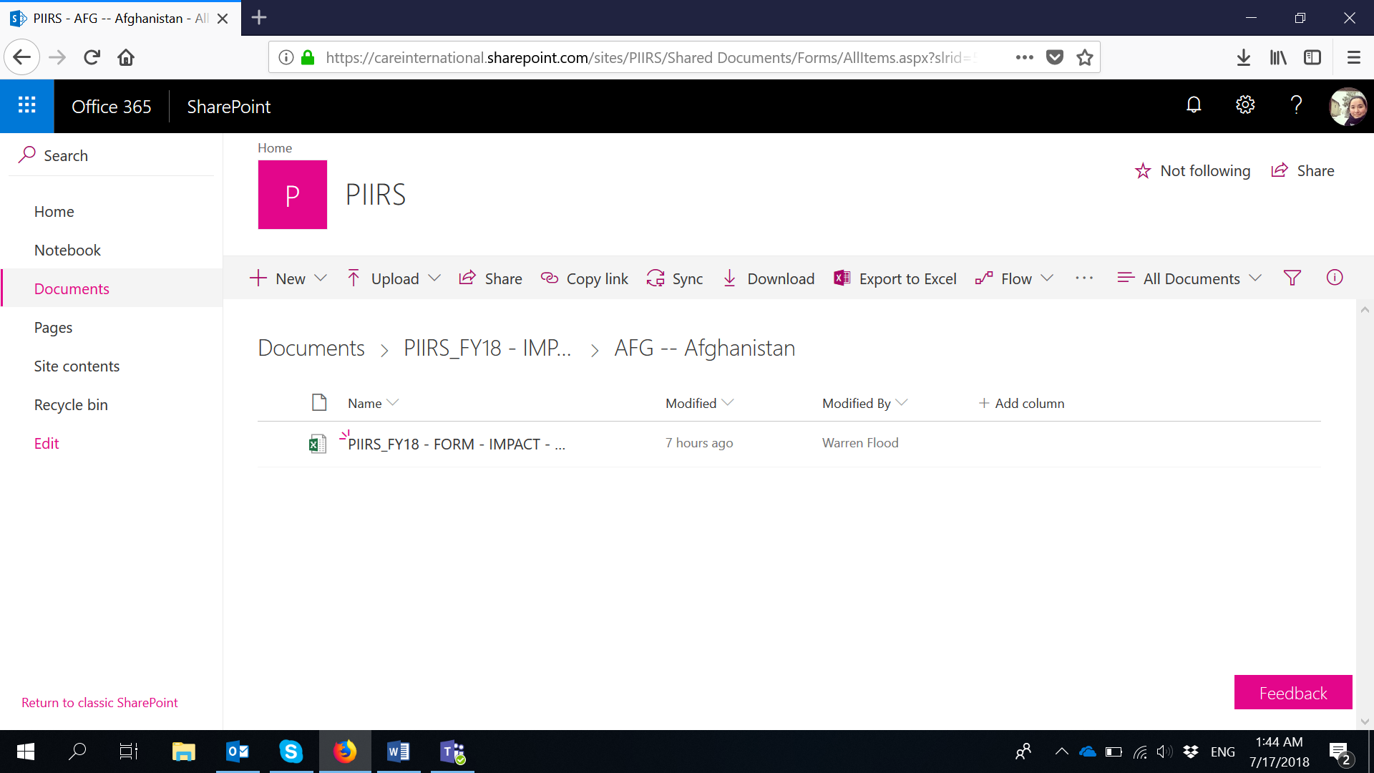  - click on the FY18 IMPACT/OUTCOMES form. Once you do that, the form will automatically open in Excel Online (pic below). IMPORTANT: AT THIS POINT, THE FORM IS NOT READY TO BE FILLED IN YET and this may be why you may see a message of “Unsupported Features…”.  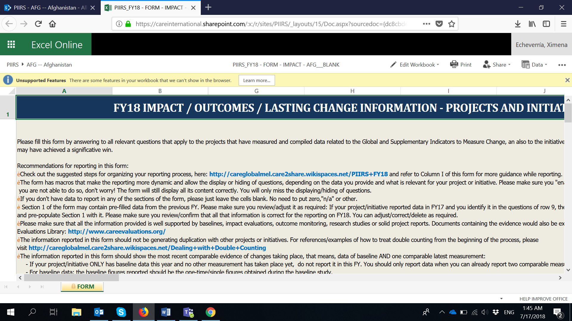  - On that same screen, click "Edit Workbook" and select "Edit in Excel".  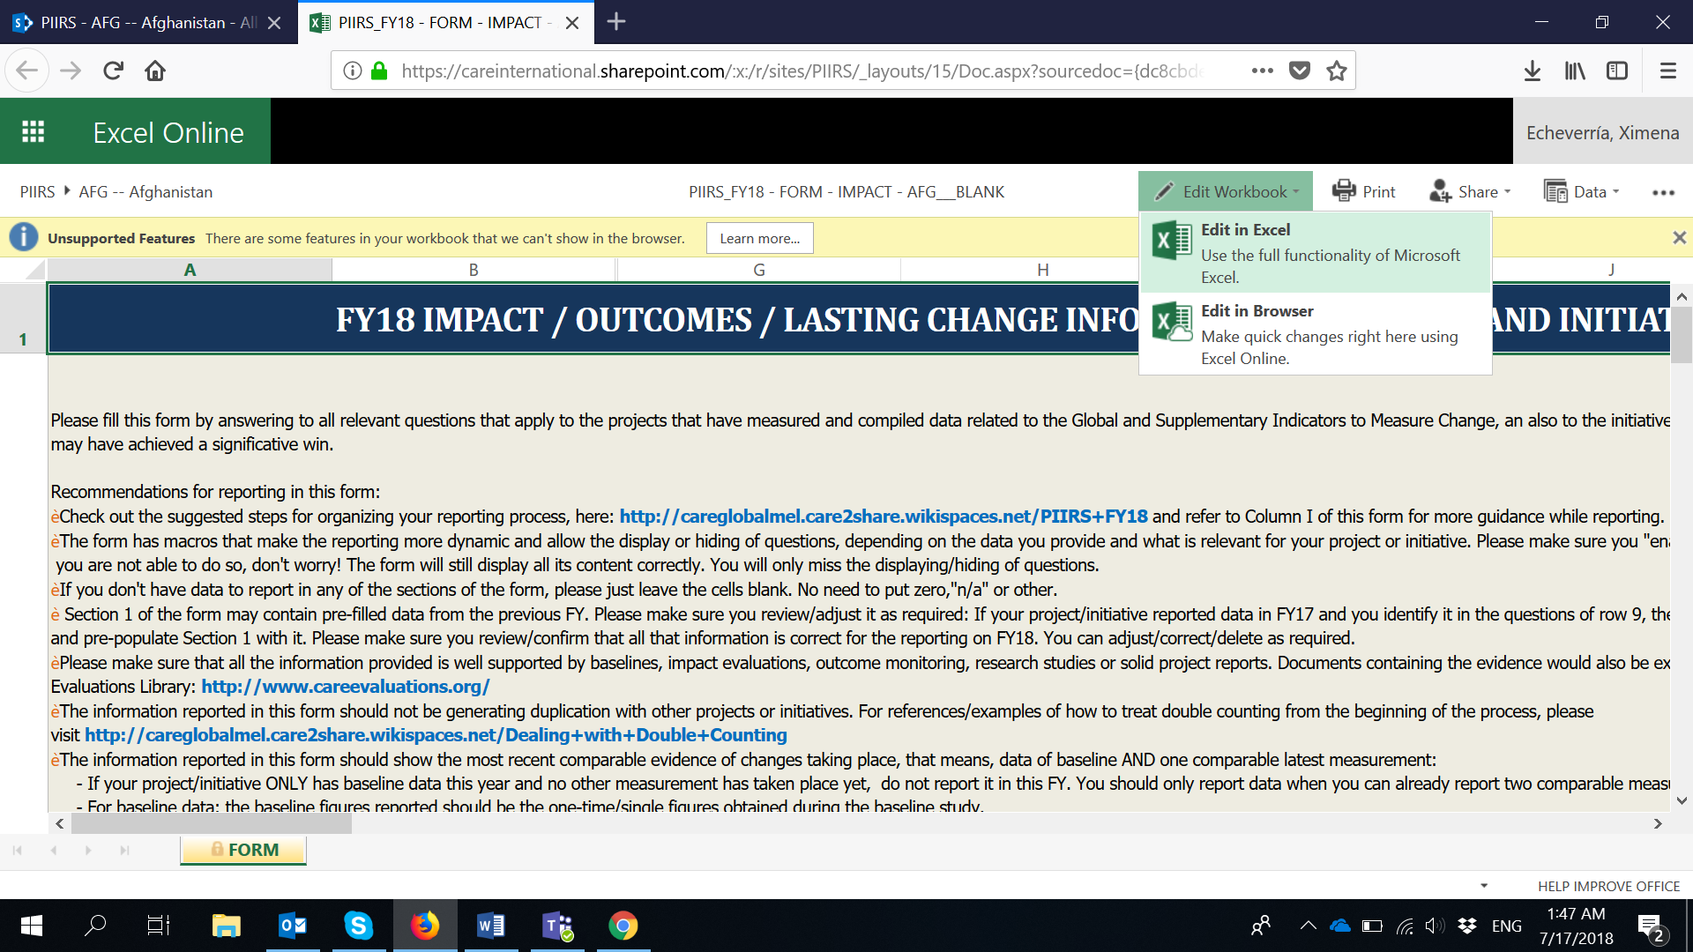  - Once the Form opens in Excel in your computer, please click on “Edit Workbook” and “Enable Content” so that the form is ready with all its features working.  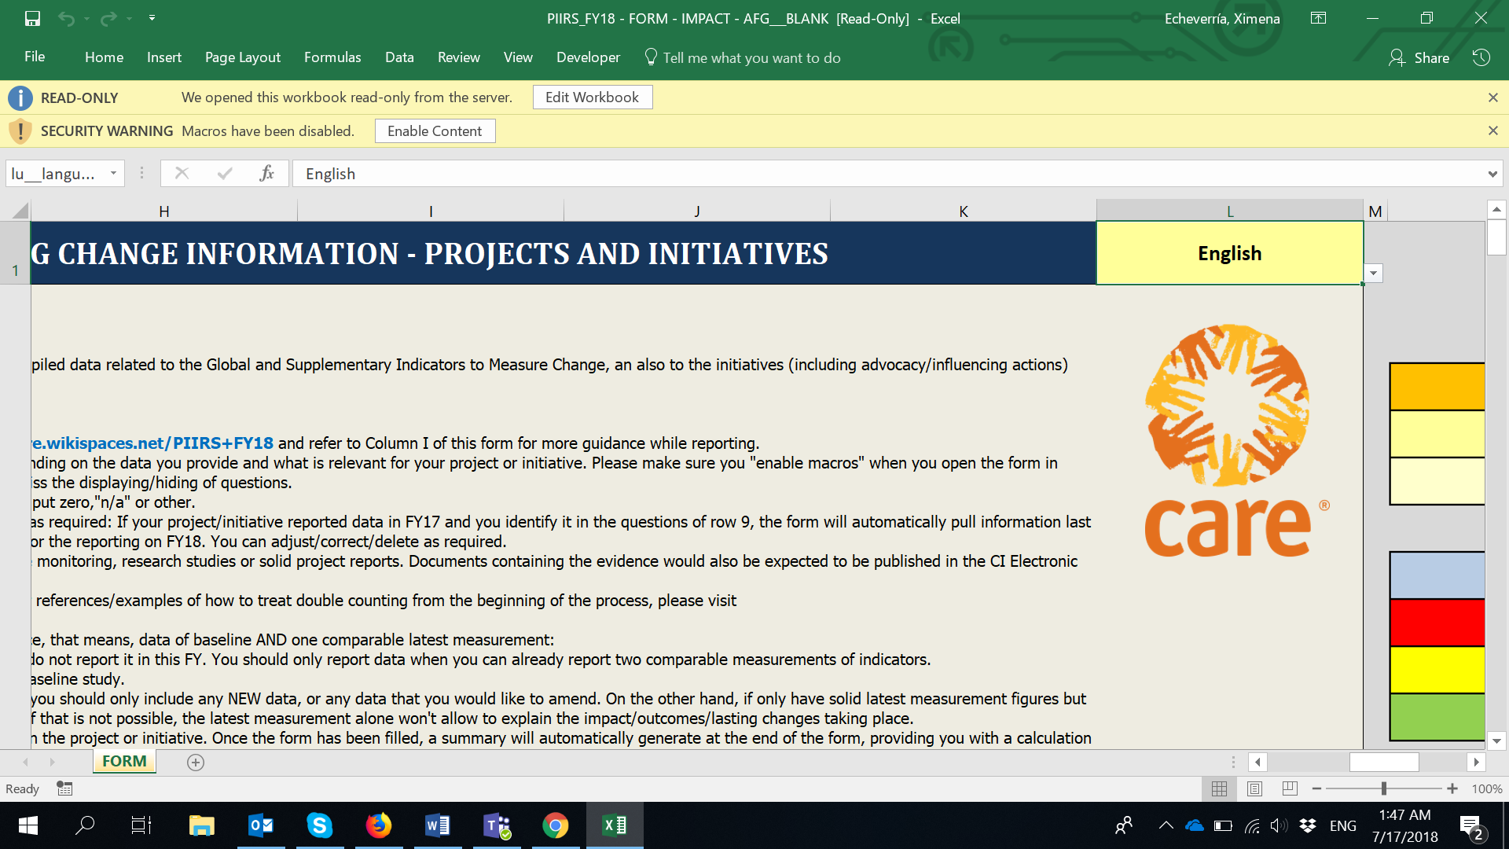  - Once you are there, with the form ready, please go to “Save as” and save as many copies of the IMPACT/OUTCOMES form as you require. That way, hoy have blank forms for all the projects/initiatives you will be reporting on. Note that when you click on “Save as”, the forms will be automatically save in your Country folder in SharePoint (not in your computer).  IMPORTANT: Please keep the original name of the file and just replace the BLANK word with any other that will identify the form with the right project/initiative. For instance:  PIIRS_FY18 - FORM - IMPACT - AFG___BLANK  PIIRS_FY18 - FORM - IMPACT - AFG___SHOUHARDOIII  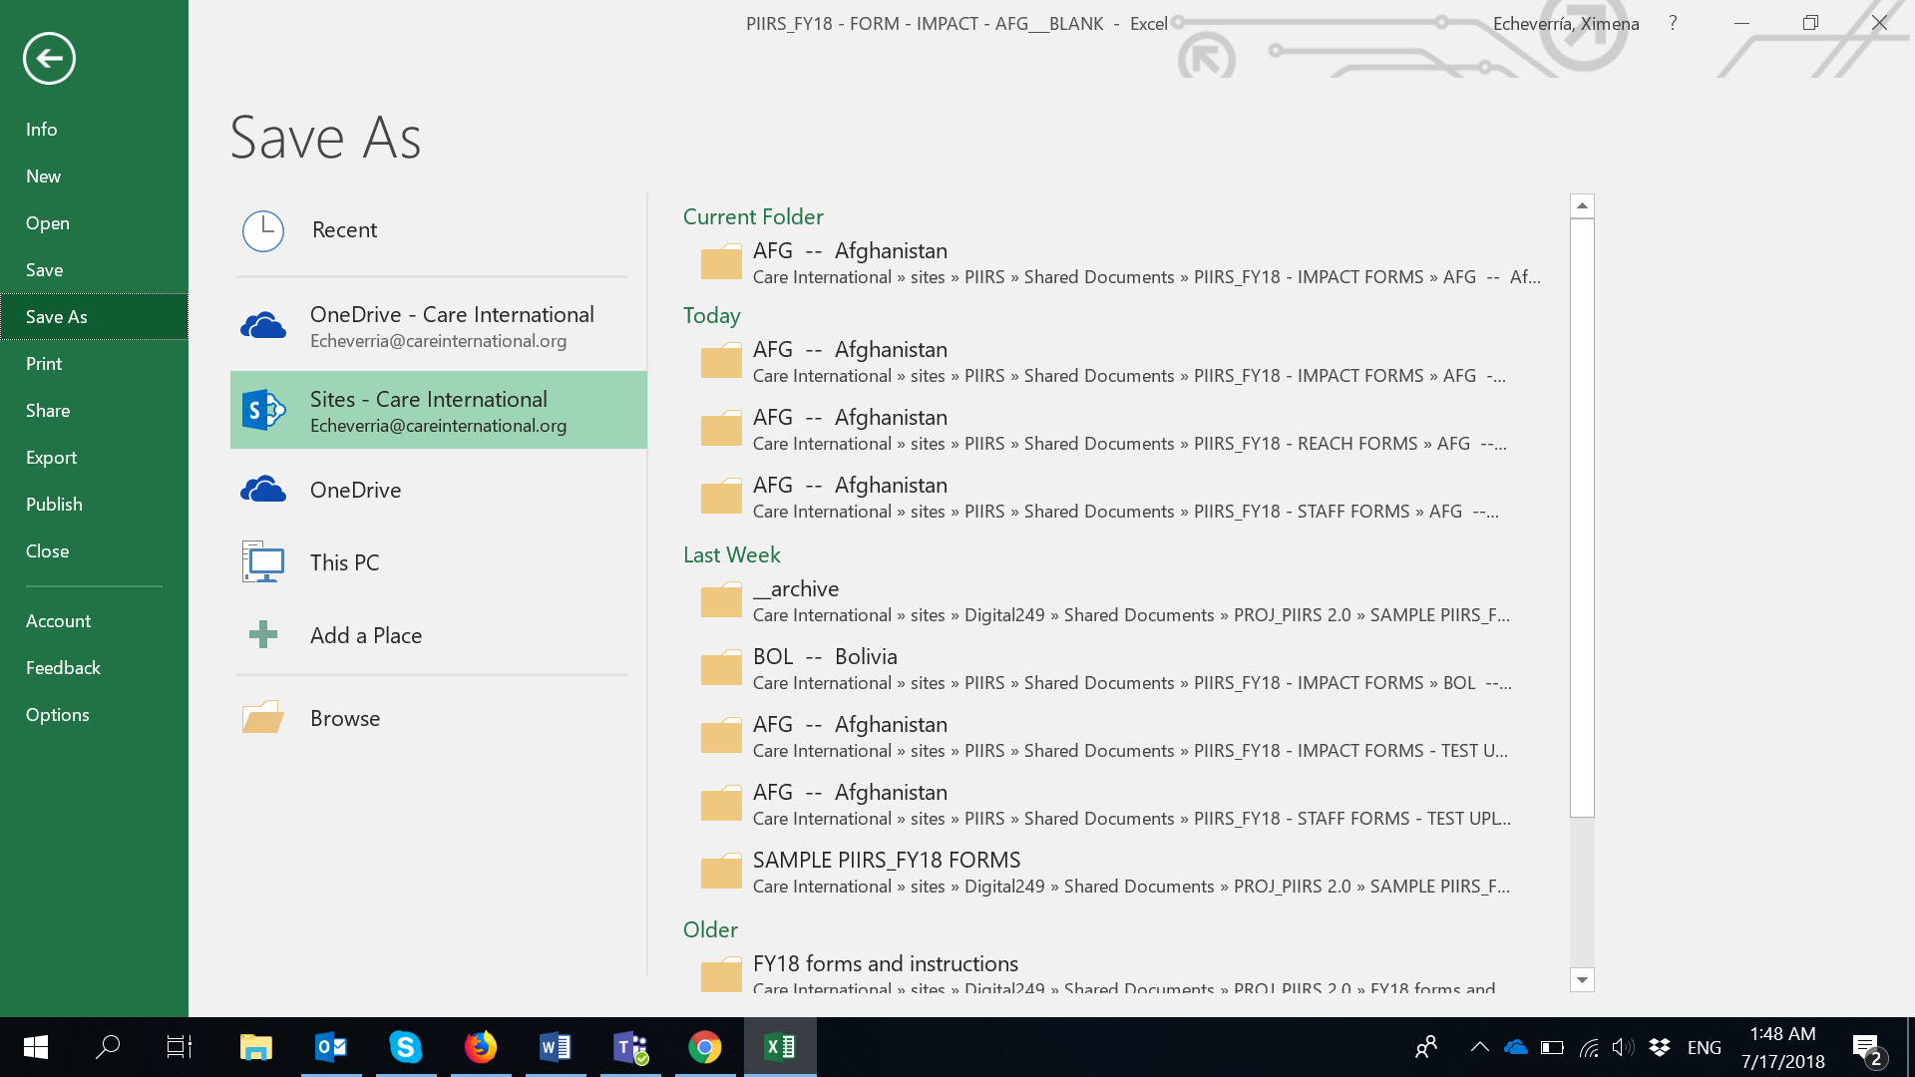  - Once you have made as many copies of the IMPACT/OUTCOMES forms as necessary, go to your Country folder in SharePoint and click on the specific FY18 IMPACT/OUTCOMES Form you will be reporting on: https://careinternational.sharepoint.com/:f:/s/PIIRS/Eshg1-Cd8IVNgAo6mBctx7ABUPYMVwC0sGUvZqYVBeG8Dg?e=2JfD0z  Once you do that, the form will automatically open in Excel Online (pic below). IMPORTANT: At this point, the form is not ready to be filled in yet. This is why you may see a message of “Unsupported Features…” popping up.  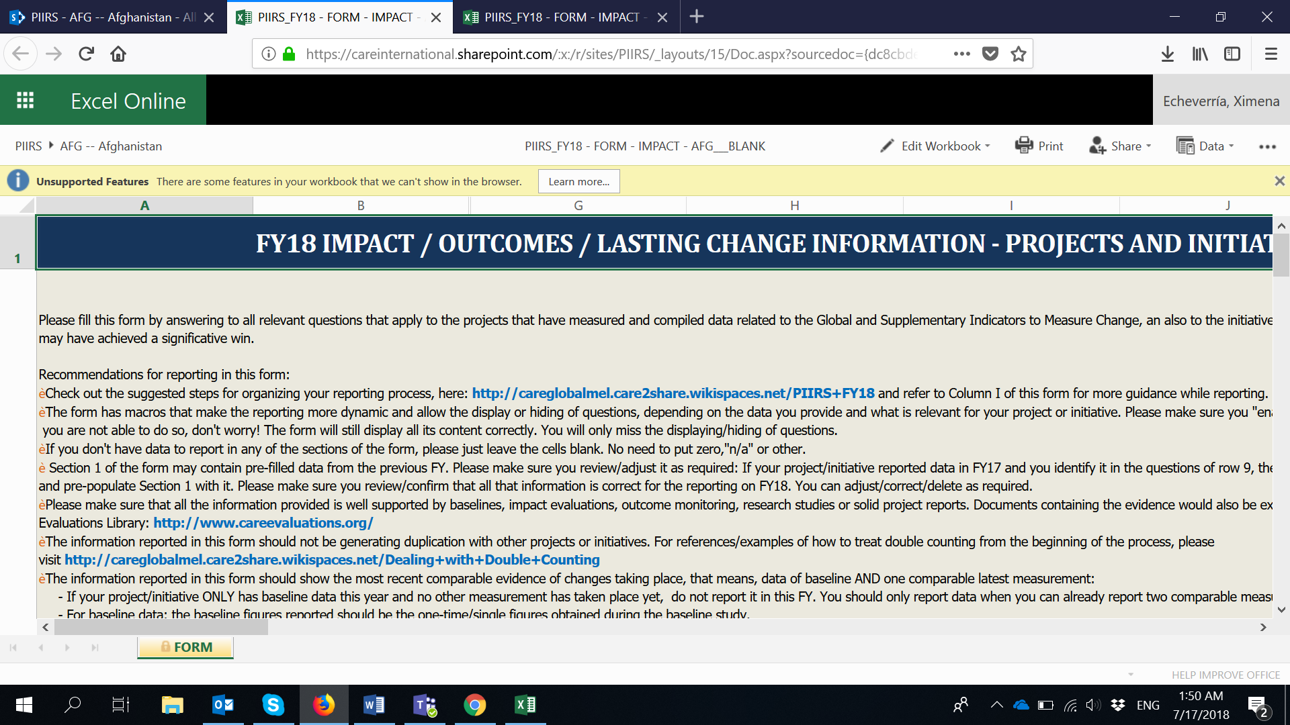  - On that same screen, click "Edit Workbook" and select "Edit in Excel".  - Once the Form opens in Excel in your computer, please click on “Edit Workbook” and “Enable Content” so that the form is ready with all its features working.  - And now you are ready to start reporting data on the form!  Note that, because you are working on O365 directly. The form will remain in SharePoint at all times (it is not downloaded in your local computer) and all changes you make will AutoSave directly in the original form that is in SharePoint . Also if you click “Save” anytime, it will still save all changes in SharePoint .  - If you want other colleagues to see/work on the form, you can always share the original link: https://careinternational.sharepoint.com/:f:/s/PIIRS/Eshg1-Cd8IVNgAo6mBctx7ABUPYMVwC0sGUvZqYVBeG8Dg?e=2JfD0z and point colleagues to your Country folder and the form you want them to review/input data on.  - If you want to share any other supporting documents that are related to the data reported in the form (e.g. marker vetting forms, evaluations documents, reports, etc.), please go to your Country’s folder using the original link to SharePoint : https://careinternational.sharepoint.com/:f:/s/PIIRS/Eshg1-Cd8IVNgAo6mBctx7ABUPYMVwC0sGUvZqYVBeG8Dg?e=2JfD0z  Click on “Upload file” and upload any supporting documents related to the data reported in the form.  - Once you have submitted the form and supporting documents, the PIIRS team will directly pull the information from it, and will get back to you if there are any questions on the data reported. | - Go to this link: https://careinternational.sharepoint.com/:f:/s/PIIRS/Eshg1-Cd8IVNgAo6mBctx7ABUPYMVwC0sGUvZqYVBeG8Dg?e=2JfD0z  - The link will take you to a SharePoint Folder containing subfolders for each CARE Country, with a BLANK FY18 IMPACT/OUTCOMES Form in each them.  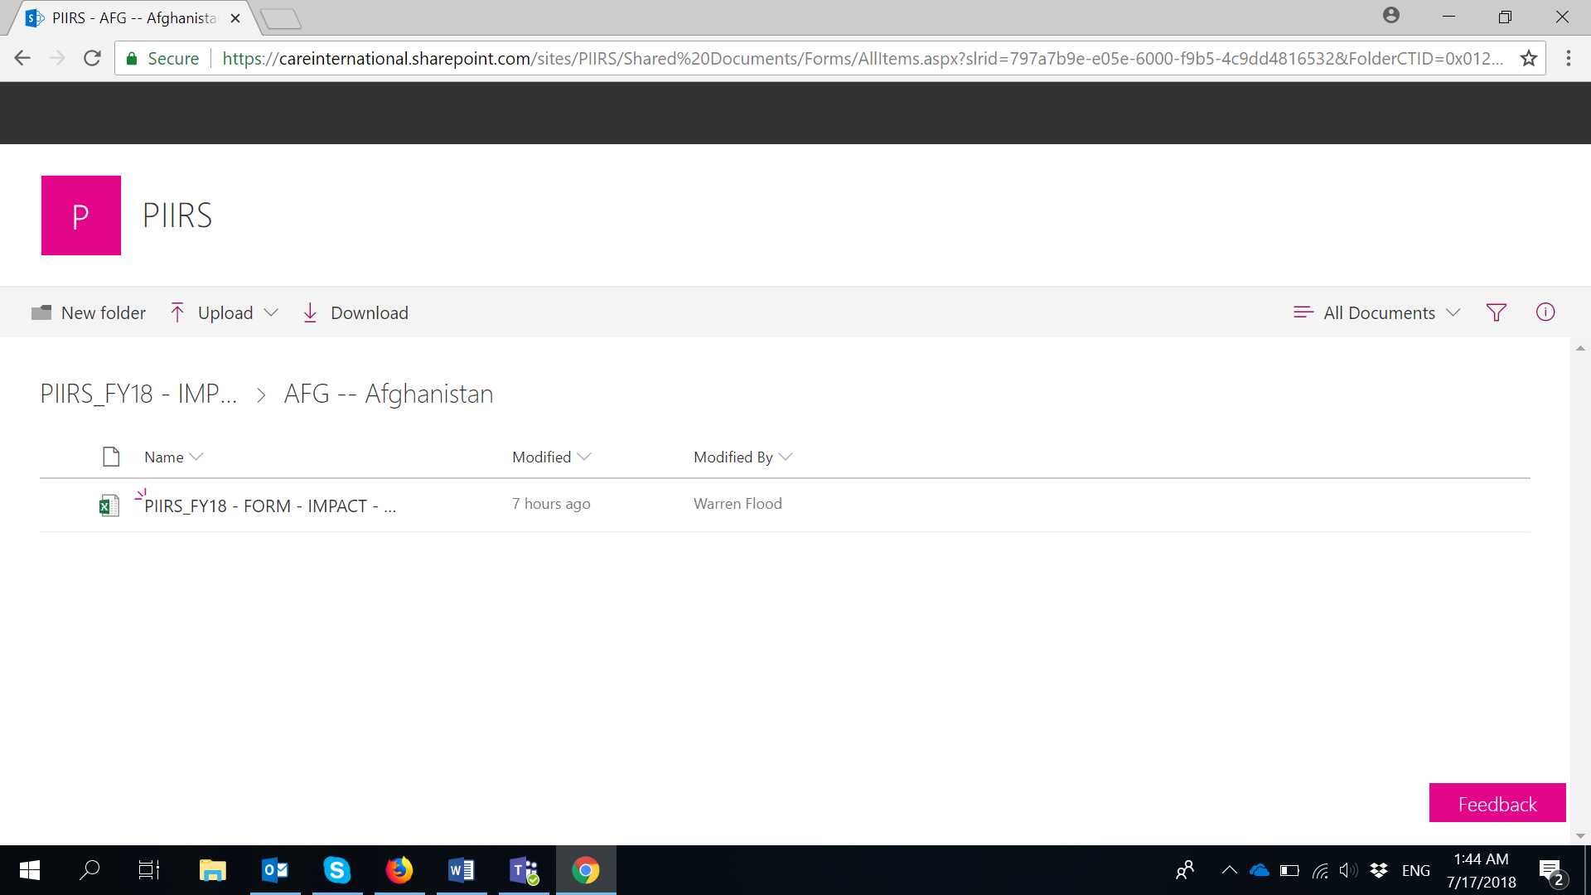  - Click on your Country folder and click on the FY18 IMPACT/OUTCOMES form. Once you do that, the form will automatically open in Excel Online (pic below). IMPORTANT: AT THIS POINT, THE FORM IS NOT READY TO BE FILLED IN YET and this may be why you may see a message of “Unsupported Features…”.  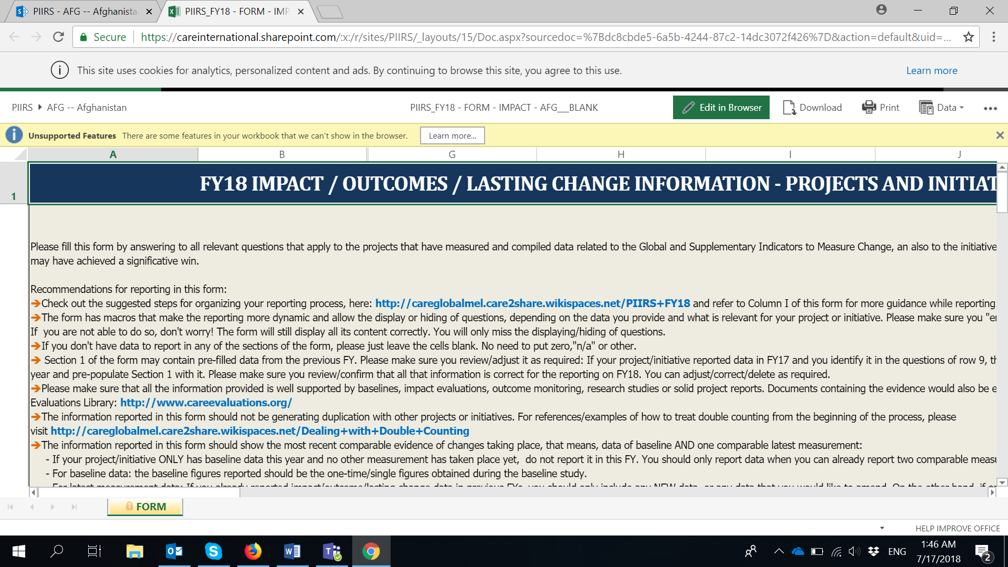  - On that same screen, click "Download" and “Yes”. Note that you may receive a message of “Features that we can't show in the browser and interactive reports will be removed from the downloaded copy.” Please ignore it and click on “Yes”.  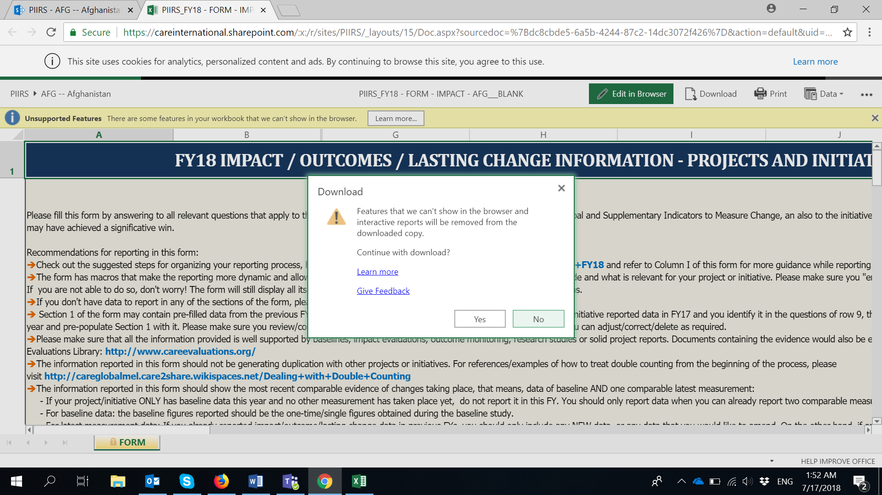  - Once you have downloaded the blank IMPACT/OUTCOMES form, you can open it in Excel in your computer, click on “Edit Workbook” and “Enable Content” so that the form is ready with all its features working.  - Once you are there, please use “SAVE AS” to save as many copies of the form as you require, in your computer.  IMPORTANT: Please keep the original name of the file and just replace the BLANK word with any other that will identify the form with the right project/initiative. For instance:  PIIRS_FY18 - FORM - IMPACT - AFG___BLANK  PIIRS_FY18 - FORM - IMPACT - AFG___SHOUHARDOIII  - Once you have saved the form(s) in your computer. You can start reporting on it/them normally.  - Once you have finished filling the form and you are ready to submit it, please go to your Country’s folder using the original link to SharePoint : https://careinternational.sharepoint.com/:f:/s/PIIRS/Eshg1-Cd8IVNgAo6mBctx7ABUPYMVwC0sGUvZqYVBeG8Dg?e=2JfD0z  Click on “Upload file” and upload the filled form you have in your computer. Once you have done so, you will be seeing multiple forms in your Country’s folder in One Drive.  IMPORTANT: Here you can also upload any other supporting documents that are related to the data reported in the form (e.g. marker vetting forms, evaluations documents, reports, etc.), following this same step.  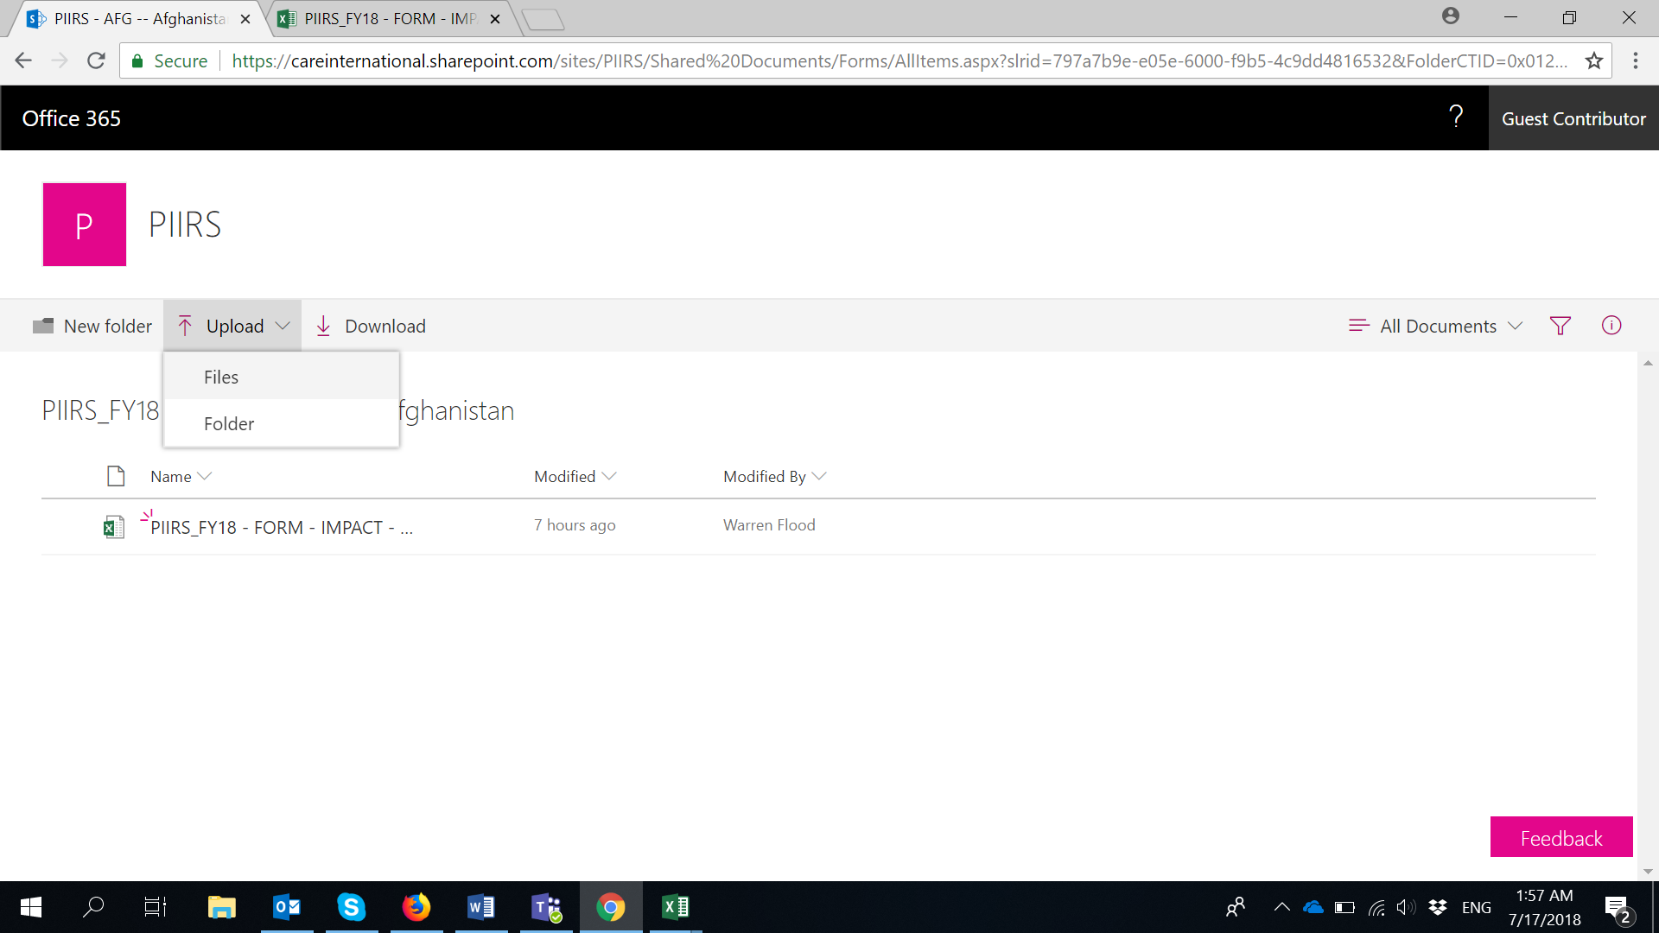  - Once you have submitted the form and supporting documents, the PIIRS team will directly pull the information from these, and will get back to you if there are any questions on the data reported. | - Go to this link: https://careinternational.sharepoint.com/:f:/s/PIIRS/Eshg1-Cd8IVNgAo6mBctx7ABUPYMVwC0sGUvZqYVBeG8Dg?e=2JfD0z  - The link will take you to a SharePoint Folder containing subfolders for each CARE Country, with a BLANK FY18 IMPACT/OUTCOMES Form in each them.  - Click on your Country folder and click on the FY18 IMPACT/OUTCOMES form. Once you do that, the form will automatically open in Excel Online (pic below). IMPORTANT: AT THIS POINT, THE FORM IS NOT READY TO BE FILLED IN YET and this may be why you may see a message of “Unsupported Features…”.  - On that same screen, click "Download" and “Yes”. Note that you may receive a message of “Features that we can't show in the browser and interactive reports will be removed from the downloaded copy.” Please ignore it and click on “Yes”.  - Once you have downloaded the blank IMPACT/OUTCOMES form, you can open it in Excel in your computer, click on “Edit Workbook” and “Enable Content” so that the form is ready with all its features working.  - Once you are there, please use “SAVE AS” to save as many copies of the form as you require, in your computer.  IMPORTANT: Please keep the original name of the file and just replace the BLANK word with any other that will identify the form with the right project/initiative. For instance:  PIIRS_FY18 - FORM - IMPACT - AFG___BLANK  PIIRS_FY18 - FORM - IMPACT - AFG___SHOUHARDOIII  - Once you have saved the form(s) in your computer. You can start reporting on it/them normally.  - Once you have finished filling the form and you are ready to submit it, please send the form(s) to piirs@careinternational.org  IMPORTANT: You can also send any other supporting documents that are related to the data reported in the form (e.g. marker vetting forms, evaluations documents, reports, etc.), following the same step.  - Once you have submitted the form and supporting documents by email, the PIIRS team will directly pull the information from these, and will get back to you if there are any questions on the data reported.

