

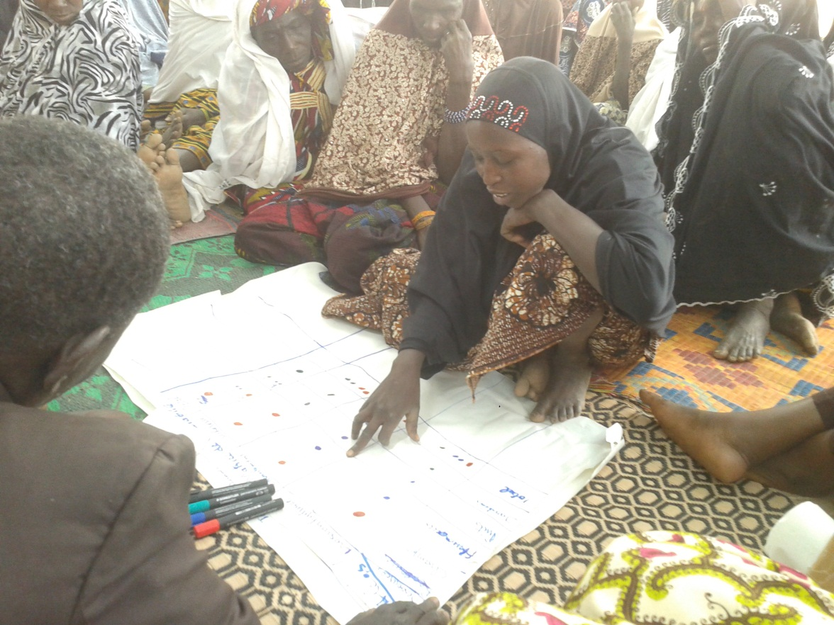

**CARE Niger’s Strategic Framework for Knowledge Management and Learning (KML)**

2017-2021

**Acronyms**

**ACD :** Assistant Country Director

**AT :** Technical Assistant

**AVVP :** Airplane, Car, Bicycle, Walking (4 modes of communication commonly used in a communications/KM package)

**CI :** CARE International

**CMI :** Impact Measurement Group

**CO :** Country Office

**CUSA :** CARE USA

**KML :** Knowledge Management and Learning

**LEFJ :** Women and Youth Empowerment and Leadership

**HR :** Human Resources

**FNS/NRM:** Food and Nutrition Security/Nartural REsources Management

**MELMI :** Monitoring, Evaluation, Learning and Measuring Impact

**ToC :** Theory of Change

**VSLA :** Village Savings and Loan Association

**SOMMAIRE**

**I.** **INTRODUCTION** - 3 -

**II.** **DEFINITION DES CONCEPTS** - 3 -

**III.** **LA ToC DU CADRE STRATEGIQUE DE GECA DE CARE NIGER** - 5 -

**IV.** **LE SYSTEME DE GECA DE CARE NIGER** - 6 -

**V.** **DISSEMINATION DES EXPERIENCES** - 11 -

**VI.** **ANNEXES** - 15 -

1. **INTRODUCTION**

CARE has worked in Niger since 1974 and has concrete results on the ground. To consolidate all of these gains and facilitate learning and using of the information about these changes, and aligning with its theory of change (TOC), CARE Niger has become a learning organization.

In order to do this, since 2010 CARE Niger has created and annual Knowledge Management plan, and has turned its Monitoring and Evaluation department into the department for Monitoring, Evaluation, Learning, and Impact Measurement (MELMI), recruited project-level knowledge managers, and put in place several internal and external working groups to build on and validate its experiences. The goal of this is to give CARE Niger the needed KML tools that link to CARE International’s strategy to facilitate communication, documentation, and knowledge sharing based on field experiences. This also helps learning about success and failure from others to improve the quality of our interventions.

1. **CONCEPT DEFINITION**

**Explicit Knowledge:** knowledge that is formally expressed and which people can easily transmit to others (data, facts, documents, etc.).

**Tacit Knowledge:** the product of individual personal experience, constituted mainly of opinions, instincts, intuitions, and competencies that are very specific to that person.

**Capitalization :** transmitting sharable knowledge and experiences.

**Knowledge :** A precise and circumscribed set of information that derives from experiences and lessons learned from the implementation of activities that are likely to bring about change or inspire more effective actions in a broader context that can feed new learning

**Knowledge Management :** Establishment of mechanisms and procedures for gathering, organizing, presenting and disseminating information in time to targets. It is also learning from other institutions and actors.

**Good practices :** experiences that have been tested, validated, and successful that are worth sharing.

**Learning Organization :** “ A learning organization is and organization who is competent in creating, acquiring, and transferring knowledge to modify its behavior in light of ne knowledge and visions.” (Garvin - 1993).

**Knowledge Hierarchy:**

**Example**

1. **CARE Niger’s Theory of Change for KML**

The process of continual reflection between CARE Niger staff and partners has allowed us to define the following TOC and strategic framework for KML:

This theory of change in CARE Niger’s KML strategic framework allows for better monitoring, as well as measuring and communicating impact through the virtuous cycle below:

1. **CARE NIGER’S KML SYSTEM**

At the CARE Niger level,there are three levels of learning:

* **Individual Learning:** In the context of performance management, all annual goals plans which integrate professional development plans include that learning products are are collected and disseminated either internally or externally (see section on disseminating experiences).
* **Collective learning:** CARE Niger has instituted a system for learning to work together and working together for learning. This cuts across the program approach, working groups, periodic meetings, and other spaces where learning products are collected and disseminated internally or externally.
* **Organizational learning:** this is part of developing a culture of learning and knowledge management, where learning products are created and disseminated (internally or externally).

It is obvious that connections exist between these three levels. The individual learning is part of different working groups which create learning spaces for CARE Niger and its partners. The graphic below outlines these connections:

The KML system that CARE Niger has put in place allows us to sustain organizational learning through the staff’s and partners’ individual learning on different CARE projects.

It rests on a detailed and permanent analysis throughout the steps of the project cycle. For each project cycle step (rows), the KM and analysis steps (columns) are applied according to the table below.

|  |  |  |  |  |
| --- | --- | --- | --- | --- |
| **4 steps for KML**  **9 project cycle steps** | 1. Transforming data into information | 2. Transforming information into knowledge | 3. Using monitoring and knowledge | 4. Improving the project cycle |
| 1. **Concept** **note/grant proposal** | Support proposal with all the evidence produced in previous projects.  Plan a budget, activities, and human resources for KML.  Consider which TOC hypotheses to test. | Put a dataplace in place with data, evaluation reports, and project closure documents. | Ask the question: What evidence or project experience would improve the proposal?  Know which actors to involve to pull out lessons learned from similar projects (completed or current). | Apply lessons learned and evidence to create relevant proposals. |
| 1. **Technical and political launch** | Train staff on KML practices and theories.  Supervise staff to deepen KML.  Target the audiences that the project wishes to influence. | Create an AVVP document package  Share documentation. | Create factsheets with the project’s expected results. | Create spaces for reflection and information use. |
| 1. **Baseline** | Host a reflection workshop on the baseline findings, including staff and partners to draw out key points  Ask the author of the baseline to present key findings, create an executive summary of key points, and generate other useful summaries. | Create an AVVP document package  Send the baseline study to the evaluations library: <http://www.careevaluations.org/default.aspx> | Share the baseline study findings | Make any necessary changes to project planning using information from the baseline study. |
| 1. **Implementation** | Manage staff to deepend knowledge management  Create reflection spaces  Collect success stoies and stories of change. | Collect and organize products from reflection spaces and working groups. | Use AVVP  Look for methods and tools that are working well.  Stay in contact with stakeholders identified during audience targeting in step 2. | Be ready to change the pieces that are not working, and reinforce or scale those that are. |
| 1. **Internal evaluations/reviews** | Create spaces for exchanging between projects and programs. |  | Conduct meta-evaluations on initiatives.  Create dissemination plans for results. | Learn from each other. |
| 1. **Mid-term evaluation** | Host a reflection event on evaluation findings, including staff and partners.  Ask the author/consultant for midterm to present key findings, create an executive summary of key points, and generate other useful summaries. | Update the AVVP package.  Send the evaluation to: <http://www.careevaluations.org/default.aspx>  Share the documents and findings | Update factsheets with mid-term findings.  Create a dissemination plan for mid-term findings and documents. | Make necessary changes to the project based on mid-term findings. |
| 1. **Update, reorient, adjust.** | Ask the question: “What do we need to change?” and have a team meeting, as well as regular learning sessions. |  | If key actors and target audiences need to make changes in their actions, conduct advocacy using available evidence. | Review documents. |
| 1. **Final Evaluation: outcomes, impacts, lessons learned, good practices.** | Host a reflection event on evaluation findings, including staff and partners.  Ask the author/consultant for evaluation to present key findings, create an executive summary of key points, and generate other useful summaries. | Update the AVVP package.  Send the evaluation to: <http://www.careevaluations.org/default.aspx>  Share the documents and findings | Update factsheets with mid-term findings.  Create a dissemination plan for mid-term findings and documents. |  |
| 1. **Closure, move to new project cycle.** | * Target projects and programs that could benefit from lessons learned. * Ask the question “what do we still need to learn to make this better?” in order to start with new learning questions. | Send final documents<http://www.careevaluations.org/default.aspx>  Share project documents |  |  |

Below are the 9 steps in the project cycle:

The 4 KML steps applied to the project cycle are:

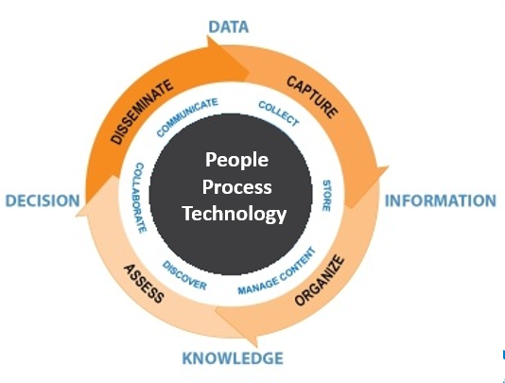

Detailed analysis of both the project cycle and KML cycle are applied to all levels of the CO:

* Country Office
* For each are: Program, Finance/audit; Admin/HR
* For each program, project, component, and program initiative.

***Who are the actors who will implement the CARE Niger KML system?***

* Country Director
* ACD ;
* Finance, Admin, and HR managers
* Program and sub-program leads
* Project managemers;
* MELMI manager
* Knowledge Managemenr and Learning Manager
* CUSA and Atlanta KML staff
* Managers at partner NGOs
* Communications and advocacy manager.

***What resources are available?***

* Automatic systems/
* Reading and writing as central skills for KML staff
* Inputs on identified themes for action research, learning thems, and products expected from the field.
* Work with media
  + - * ________
* Creating and managing partnerships, synergies, and complementarity with:
  + - * National Assembly
      * Government
      * Judicial Systems
      * Regional Authorities
      * Mayor’s offices
      * Private sector
      * Universities
      * INRAN
      * AGRHYMET
      * National Weather Service
      * ICRISAT
      * Civil Society Organizations

***Outputs***

|  |  |  |  |  |  |
| --- | --- | --- | --- | --- | --- |
| Years | 017 | 018 | 019 | 020 | 021 |
| Outputs | * ____ * ______ * _______ | * ____ * ______ * _______ | * ____ * ______ * _______ | * ____ * ______ * _______ | * ____ * ______ * _______ |

* Factsheets
* Case Studies
* Human Interest Stories
* Technical guidance
* Executive Summaries
* Reports (learning, evaluations, action research, etc.)
* Position notes on specific themes/subjects
* Audio-visual

1. **EXPERIENCE DISSEMINATION**

Caius Lucilius said “Knowledge is not knowledge if no one else knows what you know.” Additionally, you must “give the right information to the right person at the right time.”

The following tools and approaches will facilitate knowledge sharing and data protection at CARE Niger:

**L’Audience** : who is this message for? Who needs to know? What can they do with the information?

* Airplane mode for high-level decision makers
* Car mode for expert decision makers
* Bicycle mode for project managers
* Walking mode for implementers and experts in the field.
* The level of detail necessary at each of these levels as reflected in an e-mail message are:
  + Subject line: airplane mode
  + Body of the message: Car mode
  + Attachment: Bicycle mode
  + Links or places to go for more information: Walking mode.
* Communication is all about the destination

The most important rule of communication is very simple: ***consider your audience***. Most people spend all of their time thinking about “what do I want to say,” and that is only half of the equation. The other half is, “what do they want (or need) to hear.”

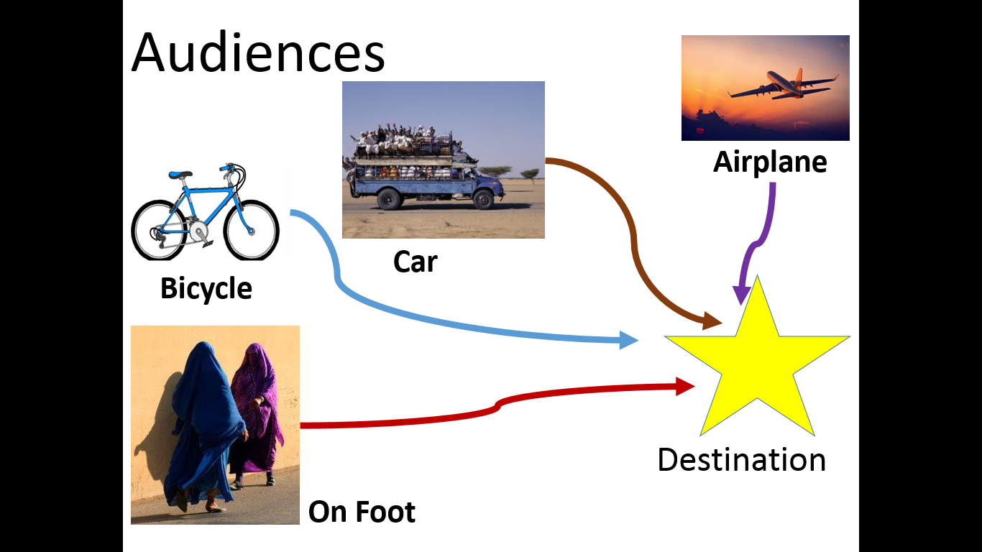Communication is about translation. In the way that a translator at the UN goes from Arabic to English, I work with information from the extremely detailed and technical to the Twitter post. As long as you have a competent translator, it’s not that either the Arabic or the English is wrong, they are just different. Some people understand one better than the other. But if you speak to someone in a language they don’t understand, you’re never going to get the message across.

Communications is a voyage. Ultimately, you want everyone to arrive at the same destination. That’s your key message. And you want all of your complex research and depth to shape what that key message is. At any level and for any audience, you always want to stay true to a core set of messages that you can back up at any depth necessary.

You want people to come to the same place—that’s your message. But there are a lot of different ways to arrive at any one place, and everyone travels a little bit differently. Each audience is going to need a specific set of details and information to get to the same place. So how are people travelling, and what do they need?

**In An Airplane**

* Who: This person might be a donor, a CEO, or an elected official. They don’t have time to get down into the weeds, and don’t always have the training to understand the nuances of every single area of the organization. It might also be the widest part of a lay audience—a customer base, small scale donors, people who could take action on your behalf.
* Information needs: Wants the 30,000 foot view. They need the high level messages, and a few brief, key highlights of the work.
* Format: These people need the shortest messages possible, and they need to be non-technical and powerful. You have a few seconds to make a big impact. Try photos, infographics, headlines, talking points, or short posts on Facebook or Twitter.

**In A Car**

* 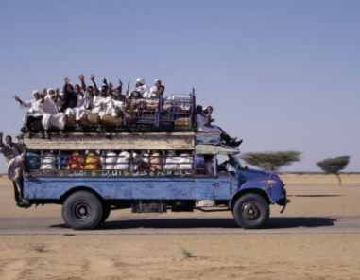Who: This person may be an interested donor, a staffer for a key decision-makers, a non-technical champion, a mid-level manager or a busy technical person.
* Information Needs: Wants a little more information to get their feet wet. They need to have a little more depth of understanding, but don’t have time to dive all the way in.
* Format: These messages should still be brief, but can contain a few more details. Try 2 page briefs, webpage posting, short blogs or op-eds, infographics with stories attached.

**On A Bicycle**

* 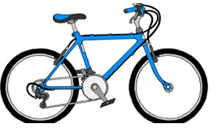Who: These are people who know about the issue and want to dig in a little more. It might be a technical specialist, an expert from a different sector, or an interested non-expert. They know enough that they need more details for you to catch their attention.
* Information Needs: These people are looking to improve their own work and build an expertise. They need enough detail to test assumptions and to adapt for new needs.
* Format: Look for formats that have more detail but are highly organized and highlighted. They need good signposting so they can find the pieces that are relevant. Journal articles, deeper reports with good executive summaries, and hyperlinked outlines/briefs are good places to start.

**On Foot**

* 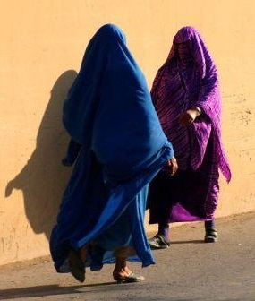Who: These people are already experts, or need to become experts quickly. It might be a technical expert, or a programmer looking to replicate results or understand a project they just picked up.
* Information Needs: These people are ready to dive into the deep end. This is the highest level of detail and complexity/nuance in messaging. They need enough detail to be able to implement programs, repeat results, carry out trainings.
* Format: You can give these guys everything you have. Full reports, project documentation, they want to see it all.
* So how do you make sure that everyone gets to the destination? Make sure that you have a version of your message that will work for everyone. Even if you only want to talk to experts, good headlines and short messages are the first way to attract anyone’s attention. ***Your short messages should always link to the more complex ones (a Twitter post 🡪 website 🡪 short brief 🡪 full report), so people can get as deep as they want.*** But you have to cross the beach to go diving, so you should ***always*** ***develop the short, high-level versions of your messaging so you can reach everyone.***

**Web Platforms:**

***Inside CARE:*** Use at least 3 internal platforms, one for each level (airplane, car, bicycle), and add details about where to go for more information. See the “platform menu”). List the platforms and the project owner here.

|  |  |  |
| --- | --- | --- |
| **Platform** | **Owner** | **Follow up (did it happen? When?)** |
|  |  |  |

***External*:** Use at least 3 extternal platforms, one for each level (airplane, car, bicycle), and add details about where to go for more information. See the “platform menu”). List the platforms and the project owner here.

|  |  |  |
| --- | --- | --- |
| **Platform** | **Owner** | **Follow up (did it happen? When?)** |
|  |  |  |

**Conferences**:

List conferences and opportunities to share our key messages here. How do we apply to present at these conferences?

|  |  |  |  |
| --- | --- | --- | --- |
| **Conference** | **Criteria and application process** | **Owner** | **Follow up (did it happen? When?)** |
|  |  |  |  |

**Communications networks:**

Spell out e-mail lists, networks, or partners we can work with to transmit our key messages.

|  |  |  |  |
| --- | --- | --- | --- |
| **List (internal or external)** | **Criteria and posting process** | **Owner** | **Follow up (did it happen? When?)** |
|  |  |  |  |

# **ANNEXES**

**Annexe 1 :** We want to maximize our learning and the use that not just the project, but also the entire organization can make of the evaluations and analyses we do. In order to accomplish this, we need to give consultants guidance on the kind of products we expect out of their TORs. An evaluation report of anywhere from 50-200 pages is not enough to help us make decisions or socialize the information. In addition to the report and data dump, we should also ask for the 10 deliverables below.

Work with the consultant to make sure that we get the products we need. Review their work periodically to make to make sure everyone is on track. Make sure to build a few days at the end of their time for review and revision. Far too often we get a product that won’t help us and a consultant who is out of time to make any changes.

1. **A Headline**: A title that actually conveys the main impact or key finding of the report. “Evaluation of XX in Y Country from 2011-2015” doesn’t tell us anything that a decent tagging system won’t do for you. Think about how newspapers write, and use the one sentence that most people will read to say the most important think you learned. This should be the subject line of e-mails you send out, the social media post you use, and the first sentence you say in every presentation.
2. **An Executive Summary:** A good executive summary lasts no more than 2 pages, and is formatted so that you could print it as a stand-alone 2 pager about the project. It contains some of your other key deliverables:
3. **3-5 key impacts/findings:** What changed as a result of the program? What actually happened in the world, and why did it matter? This is not a laundry list of everything that people did, or every single thing that changed, but the *most significant* accomplishments, supported by solid evidence. Each impact should be written as one or two sentences. For a baseline evaluation or specific analysis designed to support project decision-making, instead of impacts, focus on 3-5 key findings. What are the most important pieces of new information we learned?
4. **3-5 key lessons learned**: These should be short, actionable, and the most important aspects of what the program/analysis found. They need to be relevant and new for people outside of the direct program. For example: “women’s empowerment has a bigger impact on nutrition than anything else” is a revolutionary finding that spans all kinds of programs; “poor management leads to program delays” only tells us what we already know.
5. **3**-**5 bullets describing *how* the project got to impact/3-5 recommendations**: It is important to have non-jargon descriptions of what a project did to get to impact. Again, this is not a laundry list of every activity, but highlights of the most effective, relevant, and scalable approaches and tools. If this is an analysis and not an evaluation, then this section should be 3-5 key recommendations for what the project should do based on your findings.
6. **A power point presentation:** Once you have your executive summary with its headline and highlights, you can use that to build your powerpoint presentation—because someone is going to have to present this work to at least one audience if you want it to go anywhere. Rules to remember for a good power point:
   * **No more than 6 words per slide**—the 6 word summaries of lessons/impacts will be extremely helpful to put together social media and e-mail subject lines for relevant audiences
   * **Use visuals and photos**—these are also great for formatted briefs, infographics, social media, and catching the human element
   * **Focus on relevance to your audience**—people pay much more attention if you are helping them do their job than if you are telling them about yours.
   * **No Excel tables**—they’re too small to read and usually don’t tell a story.
7. **Human connections:** People—even the most expert and jaded among us—learn better if they can connect to something that feels real to them and they can see how it matters for themselves and others. That means an evaluation package should include:
8. **Photos** that show impact and tell a story. Photos of focus groups answering questions or workshops do not make the human connection
9. **Quotes and Human Interest Stories:** Besides being great for websites and social media, these quotes help capture the reality of changes as people on the ground see them. They remind us why the numbers matter, and how we can change lives. Evaluators are in a unique position to gather these as they visit communities to collect information because they are the ones who get to talk to other humans.
10. **A FINALIZED Evaluation:** It is shocking how often I receive evaluations that are 2-3 years old that are still marked “Draft” and were never finalized. No evaluation will ever be perfect, but no one will ever take it seriously if it’s marked “Draft” forever, because they’ll never think they have the right one. The consultant TOR should include the need for a final evaluation before they get the last payment.

**Annexe 2 : Significant Change Story Template**

This template is intended to be used by project and program implementers to identify and provide a compelling account of an individual, a community, approach, intervention, specific activity, or lesson learned over time. Each section in the template is followed by a self-check list, which outlines criteria relevant to that section.

**1. IDENTIFY The Situation (what was the situation before the Change):**

|  |
| --- |
|  |

***SELF-CHECK*** *–* ***Have you:***

* *Described the problem being addressed and why it’s important?*
* *Introduced the focal point – the person, people, activity, etc.?*
* *Used context and data to frame the issue, including any relevant information about the subject and the context?*
* *Where relevant, included at least one compelling quote?*

**2. PROVIDE AN OVERVIEW OF the initiative/intervention**

|  |
| --- |
|  |

***SELF-CHECK – Have you:***

* *Identified the ‘cause’ in the ‘cause and effect’? It’s important to mention specific actions (activities, intervention, or otherwise) that directly impacted the change.*
* *Included who was involved, including any partners, volunteers, etc.*

**3. Program impact: What is the change and why is it significant?**

|  |
| --- |
|  |

***SELF-CHECK – Have you:***

* *Demonstrated how the program/activity resulted in change (e.g., behavior change, improved advocacy, etc.)*
* *Explained the significance of the change by answering the questions So What? and Now What?*

**4. case study title (should be succinct and catchy):**

|  |
| --- |
|  |

***SELF-CHECK*** *–* ***Have you:***

* *Captured the overall message of the story?*
* *Included an action verb?*
* *Captured the reader’s attention, even if the person cannot relate to the subject matter or has little or no familiarity with the subject?*

**5. Overall Style Reminders**

* Keep paragraphs short – no more than 5-6 sentences
* People outside of international development should enjoy reading the story
* Story should have a narrative flow, with a beginning, middle and end
* Story should not exceed one and a half pages
* Keep it simple; avoid flowery language and keep messages short and concise
* Include quotes if they strengthen the story
* For photos, the larger the file, the better the result. Jpegs are preferred.

**Annexe 3 :** model de factsheet



**CARE** Titre de l’unité ou de secteur

<EMPTY>**Nom du projet ici**

**S’il est long, le nom du projet peut continuer**

**Nom du projet:** [Nom] (Acronyme)

**Le Pays/Les pays :**

Si les pays ne se mettent dans une seule ligne, faire aligner à la droite et les mettre ici.

**Periode:** Mois, Année – Mois, Année

**Budget:** US$ XX million

**Bailleurs de Fonds:** Nom de bailleur

**Impact:**

Les chiffres et les statistiques qui montre l’impact, les outcome, et les résultats en chiffres (ex: nombre de personne touches, etc.

Utilise la taille 10 pour le style des mots. font here is set at 10 pt. Obis magnatin prat. Voloreheni doluptat harchil int quodic tem eate m X e rion.

**Introduction à [Nom du projet]**

Une page, deux côtés. Ce format contient les aspects qui puissent être utilisés dans la création d’un document d’une page, deux côtés. Les composantes qui ne sont pas utiles puissent être enlevées.

Garez en tete les standards du brand de CARE, disponible sur le net a: [**www.carebrandstandards.org**](http://www.carebrandstandards.org).

**OBJECTIVE**

* Cliquez les boites gris pour insérer les photos. Assurez-vous que les photos sont coupes dans une façon agréable.
* Les tableaux et les graphiques sont des exemplaires seulement. En adaptant, assurez-vous que les tableaux soient simple, lisible, et facile à comprendre.
* Espacement des lignes est 15 pts exacts.

**STRATEGY**

La taille du texte et 11pt dans le style ITC Officina Sans Book à 100% noire. Les titres sont à 14 point. Alignement est JUSTIFIE

Obis magnatin prat. Voloreheni doluptat harchil int quodic tem eate m X e rion sequiam hic tem veres ipsandae non conecupici ra as doluptas dolum ipsam, si omnistin re, que poreheni se era cus rem vel ideles qui si dolo inverumquate.Ria acitios Obis magnatin prat. Voloreheni doluptat harchil x tem eatemXerionsequiam hic tem veres ipsandae non conecupici ra as doluptas dolum ipsam, si omnistin re, que down within their columns or deleted to fit with your document. Obis magnatin prat. Voloreheni doluptat harchil int quodic tem eate m X e rion sequiam hic tem veres ipsandae non conecupici ra as doluptas dolum ipsam, si omnistin re, que poreheni se era cus rem vel ideles qui si dolo inverumquate.Ria acitios Obis magnatin prat. Voloreheni doluptat harchil x tem eatemXerionsequiam hic tem veres ipsandae non conecupici ra as doluptas dolum ipsam, si omnistin re, que down within their columns or deleted to fit with your document. Voloreheni doluptat harchil int quodic tem eate hic tem veres ipsandae non conecupici ra as doluptas dolum ipsam, que poreheni se era cus rem vel ideles qui si dolo inverumquate.Ria acitios Obis magnatin prat. Voloreheni doluptat harchil x tem eatemXerionsequiam hic non que down within their columns or deleted to fit with your document. Voloreheni doluptat harchil. Obis magnatin prat. Voloreheni doluptat harchil int quodic tem eate m X e rion sequiam hic tem veres ipsandae non conecupici ra as doluptas dolum ipsam.

<EMPTY>

© PHOTO CREDIT EXIGEE ICI

© PHOTO CREDIT EXIGEE ICI D



**CARE Office Name**

*Person of contact,* email address

T: 555.555.5555

F: 555.555.5555

emailaddress@care.org

**Regional Office Name**

**City, Country**

T: 555.555.5555

F: 555.555.5555

emailaddress@care.org

© PHOTO CREDIT EXIGEE ICI

**TITRE**

Obis magnatin prat. Voloreheni doluptat harchil int quodic tem eate m X e rion sequiam hic tem veres ipsandae non conecupici ra as doluptas dolum ipsam, si omnistin re, que poreheni se era cus rem vel ideles qui si dolo inverumquate.Ria acitios Obis magnatin prat. Voloreheni doluptat harchil x tem eatemXerionsequiam hic tem veres ipsandae non conecupici ra as doluptas dolum ipsam, si omnistin re, que down within their columns or deleted to fit with your document. Obis magnatin prat. Voloreheni doluptat harchil int quodic tem eate m X e rion sequiam hic tem veres ipsandae non conecupici ra as doluptas dolum ipsam, si omnistin re, que poreheni se era cus rem vel ideles qui si dolo inverumquate.Ria acitios Obis magnatin prat. Voloreheni doluptat harchil x tem eatemXerionsequiam hic tem veres ipsandae non conecupici ra as doluptas dolum ipsam, si omnistin re, que down within their columns or deleted to fit with your document. Obis magnatin prat. Voloreheni doluptat harchil int quodic tem eate m X e rion sequiam hic tem veres ipsandae non conecupici ra as doluptas dolum ipsam, si omnistin re, que poreheni se era cus rem vel ideles qui si dolo inverumquate.Ria acitios Obis magnatin prat. Voloreheni doluptat harchil x tem eatemXerionsequiam hic tem veres ipsandae non conecupici ra as doluptas dolum ipsam, si omnistin re, que down within their columns or deleted to fit with your document. Obis magnatin prat.

**TITRE**

**Sous Titre**

The Title in all caps is set at 14 pt and the Section Title is set at 12 pt. Voloreheni doluptat harchil int quodic tem eate m X e rion sequiam hic tem veres ipsandae non conecupici ra as. Tem veres ipsandae non conecupici ra as doluptas dolum ipsam, si omnistin re, que down within their columns or deleted to fit with your document.

**Sous-Titre**

Ria acitios Obis magnatin prat. Voloreheni doluptat harchil x tem eatemXerionsequiam hic tem veres ipsandae non conecupici ra as doluptas dolum ipsam, si omnistin re, que down within their columns or deleted to fit with your document. Obis magnatin prat. Voloreheni doluptat harchil int quodic tem eate m X e rion sequiam hic tem veres ipsandae non conecupici ra as doluptas dolum ipsam, si omnistin re, que poreheni se era cus rem. Ria acitios Obis magnatin prat. que down within their columns or deleted to fit with your document. Obis magnatin prat. Voloreheni doluptat harchil x tem eatemXerionsequiam hic tem veres ipsandae non conecupici ra as doluptas dolum ipsam, que down within their columns or deleted to fit with your document.

For more information, contact [nameofcontact@care.org](mailto:nameofcontact@care.org) or visit [www.URL.com](http://www.URL.com).

© PHOTO CREDIT REQUIRED

***“On peut mettre une citation des bénéficiaires, partenaires, etc.”***

* ***Titre et Nom de celui qui a dit***

**Impact:**

Encore des chiffres qui demontre l’impact qu l’on a eu, les outputs, etc.

Obis magnatin prat. Voloreheni doluptat harchil int quodic tem eate m X e rion sequiam hic tem veres ipsandae non conecupici ra as doluptas dolum ipsam, si omnistin re, que poreheni se era cus rem vel ideles qui si dolo inverumquate.Ria acitios Obis magnatin prat. Voloreheni doluptat harchil x hic tem veres ipsandae non conecupici ra as doluptas dolum ipsam, si omnistin que down within their columns or deleted to fit with your document. Obis magnatin prat. Voloreheni doluptat harchil int quodic tem eate m X e rion sequiam hic tem veres ipsandae

COPYRIGHT AND CREDITS

MONTH YEAR : AUTHOR