Reporting CARE'S Carbon Footprint and Climate-Smart Practices in PIIRS
Guidance Note
This guidance document provides information for all CARE offices (Country offices, Candidates, Members, Affiliates) on how to report greenhouse gas (GHG) emissions and climate-smart practices into PIIRS.
Contents

I. Introduction 2
II. How to report CARE’s carbon footprint and climate-smart practices in PIIRS 2
Step 1 Flights and greenhouse gas emissions during the FY 3
Step 2 Fuel consumption for vehicle use during the FY 6
Step 3 Office(s) energy consumption during the FY 6
Step 4 Measures your office has taken to reduce and/or offset emissions in the FY 10

Introduction
what is a climate-smart organization
A climate-smart organization measures its emissions, reduces them as much as possible and compensates its unavoided emissions.

As an organization dedicated to addressing the underlying causes of poverty and social injustice, CARE is a serious advocate for an urgent, effective and equitable response to climate change. This includes an ambitious commitment by CARE itself to adopt practices that reduce GHG emissions that are causing climate change.
According to the 2018 milestone “Global warming of 1.5 degrees” report by the Intergovernmental Panel on Climate Change (IPCC), global net anthropogenic CO2 emissions should decline by about 45% from 2010 levels by 2030, reaching net zero around 2050 to keep the possibility of limiting global warming to 1.5°C above pre-industrial level. A tremendous level of effort is thus needed globally.
To remain within a global temperature increase of 1.5°C, global GHG emissions in 2030 need to be approximately 55 percent lower than in 2017 (IPCC, 2018). In tonnes CO2e emissions, this would mean going from an average of 4.8 tonnes CO2e per capita in 2017 to 2.3 tonnes CO2e per capita in 2030. In comparison: a direct round trip flight from Paris to New Delhi produces 3.4 tonnes of CO2e emissions, which is far more than the 2030 climate compatible annual emissions budget for one person.
Reporting on CARE’s carbon footprint and climate-smart practices is a part of CARE’s Program Information and Impact Reporting System (PIIRS), and is done for the following purposes:
- To have an annual global overview of the total amount of GHG emissions generated by CARE
- To have a global overview of the total amount of GHG emission reductions by CARE over consecutive years
- To have a global overview on the types of measures developed by CARE offices to reduce and/or to offset emissions.
- To generate information that supports reflection and learning around good practices to reduce emissions and about areas that require improvement and support.
All data retrieved will be analysed and results will be shared with all CARE offices in an annual report.

How to report CARE’s carbon footprint and climate-smart practices in PIIRS
Calculating GHG emissions is a multi-step process. There are three main sources of GHG emissions in CARE offices: flight related emissions (i), vehicle related emissions (ii) and office energy consumption related emissions (iii).
which office information should be reported in piirs?
Each CARE office is asked to report on the gathered information of all its different offices in the country. For example, CARE USA will report on the emissions related to its Atlanta Headquarters and all the sub-offices in the USA but will not report on the emissions of the Country Offices it leads in the Global South. CARE Uganda will report on the emissions of its national office in Kampala and all its sub-offices in Uganda.

Recommendation: Experience has shown that it is preferable to monitor emissions on a continuous basis – using a live spreadsheet or database – rather than calculate emissions in one large annual number-crunching exercise. Not only does this make the task more manageable, but it also keeps the topic alive and increases staff’s awareness. See below an example of a spread sheet for flight-related emissions 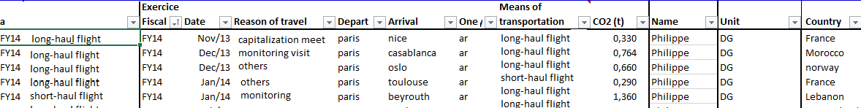:

Step 1 Flights and greenhouse gas emissions during the FY

The impact of air travel
One return flight from Atlanta to Nairobi and back generates almost 10 tonnes of CO2e emissions (www.atmosfair.de), which is more than the average total annual emissions of a European citizen (ca 7.7 tonnes CO2e per year in 2017) and almost 10 times the average total annual emissions of a Malagasy citizen (0.1 tonnes CO2e per year in 2017).

PIIRS Question: Number of (#) flights under 2 hours of flight time (i), number of flights over 2 hours of flight time (ii), total number of hours of all flights (iii) and total number of flights (iv)
Print screen PIIRS

Flights covering longer distances (for example from Bonn to Maputo) generate a lot of emissions. But short flights (for example from The Hague to Geneva) are also very harmful for our climate as it is during take-off and landing that most energy is used. For this reason, the PIIRS form makes a distinction between flights over two hours and below two hours as short flights can often be substituted through other means of transport and should therefore be avoided where possible.
Under this question, it is important to report the number of flights paid for by your office for both staff and consultants. In addition, when reporting flights that have intermediate stops, consider them as one flight and include the total hours of flying. For example, if you had a travel that consists of a one hour long flight, an intermediate stop and another flight of 6 hours, report it is as “one flight over 2 hours”. This should thus not be counted as two separate flights (‘’one flight under two hours of flight time’’ and one ‘’over two hours of flight time’’).

PIIRS Question: Total amount of GHG emissions (in tCO2-equivalent) from flights that were supported by your office
Print screen PIIRS

This question provides an overview of the total amount of emissions from flights paid for by your office (also for external consultants). You can calculate your office flight emissions yourself with an online tool or ask an external organization to do it for you. The most important thing to keep in mind is to be consistent: so use the same calculation methodology over the years.
If you choose to do the calculation of emissions yourself, it is recommended to use the online calculator “Atmosfair”. This calculator can be found via the following link: https://www.atmosfair.de/en/offset/flight. Atmosfair takes into account intermediate stopovers (which add to your footprint, as landing and take-off use most energy) and non-CO2 factors. Other online calculators do exist but have different ways of calculating emissions and are not always accurate.

When using Atmosfair, this is what you will see:
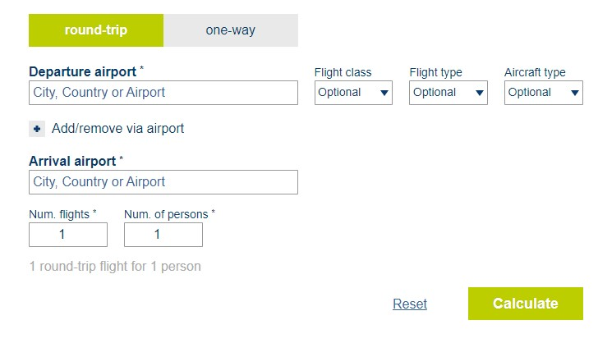
The Atmosfair calculator requires your input for departure and arrival airports. Reporting any stops in between is also required. Your input is also needed for the cabin class (first, business, economy), flight type (scheduled or chartered) and aircraft type. This information can be found in your travel itinerary provided by your travel agency or in your online travel details. Based on this information, Atmosfair will calculate your flight emissions.
Below is an example of calculating a trip from Paris to New Delhi, with a stopover in Dubai. This is an economy class trip on a scheduled flight, on an Airbus A330-200:
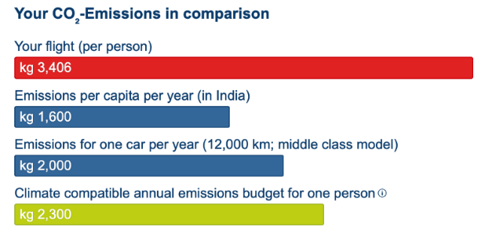
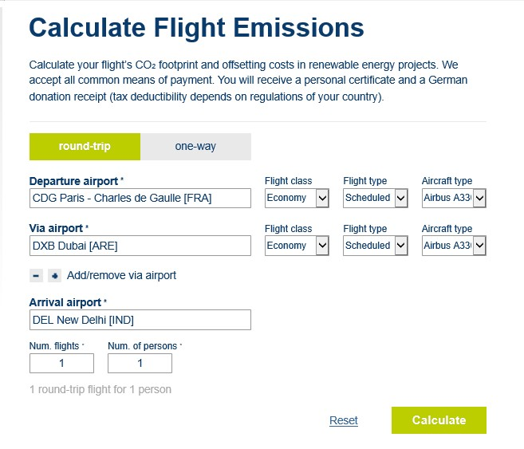
This round-trip from Paris to New Delhi produces 3,406 CO2e kg emissions..
Recommendation: CARE staff could be asked - in their travel/ booking form to calculate the teqCO2 emissions for their potential travel, which is a good way to gather the information for this PIIRS question. All staff should use the same calculator for this (CARE recommends to use the online calculator “Atmosfair’’). Below is an example of what the travel form could look like.

Step 2 Fuel consumption for vehicle use in the FY

PIIRS question: Number of litres of a) gasoline b) diesel c) other fuels
Print screen PIIRS

what is the impact of vehicle emissions?
The Energy Saving Trust¹ Limited calculated that a journey from London to Edinburgh for one passenger, would generate around 144 kg CO2e by plane, 115 kg CO2e with a diesel car, 120 kg CO2e with a gasoline car and 29kg CO2e by train.

This question allows for the estimation of emissions from vehicle use by your office. Note that only vehicles used for projects purposes, by your staff and consultants, should be considered. This question does not include daily office commuting by your office staff.
There is a direct link between fuel consumption and CO2e emissions. Cars that use more fuel emit more CO2e, and some fuels are more harmful to the environment than others: for example, diesel produces about 2.70 kg CO2eq/litre, gasoline about 2.32 kg CO2eq/litre and ethanol about 1.52 kg CO2eq/litre. Having fuel consumption per type of fuel reported in PIIRS will allow for a calculation of GHG emissions, using corresponding emission factors.

Step 3 Office’s energy consumption during the FY
Print screen PIIRS

Fuels, green energy and GHG emissions
For many organizations, purchased electricity represents one of the largest sources of GHG emissions and the most significant opportunity to reduce these emissions. Natural gas emits significantly less GHG than coal, but more than solar or wind. Natural gas remains an important CO2e emitter that has to be taken into account in your office energy consumption calculation.

PIIRS Question: Electricity in kWh, consumed by your office(s)
The total amount of kWh used by your office during the FY would normally be available in the metered electricity consumption or utility bills specifying consumption in MWh or kWh units.

PIIRS Question: CO2 intensity in grams of CO2 equivalent per kWh
The CO2 intensity provides the means through which we can calculate the total amount of CO2e emitted through office energy consumption on the basis of the electricity consumption in kWh.
Energy providers often indicate energy intensity information in electricity bills. In some countries the term ‘CO2 emission intensity’’ is used and in other countries ‘’CO2 emission factors’’. In both cases it is understood to be GHG emissions (in CO2 equivalence) per activity (either in electricity used, fuel used, or gas used). Below are two examples of electricity bills from Ireland (Electric Ireland) and Australia (Origin Energy):
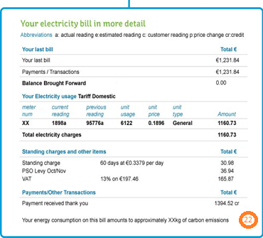#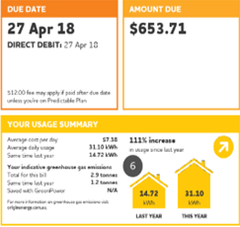
Looking at Electric Ireland’s sample bill on the left: point 22 is where carbon emissions are listed directly in kg. In the Origin Energy’s sample bill on the right: at point 6 is where carbon emissions are listed directly in kg.

If your energy provider cannot give you this information, provide us with the CO2e emission factor indicated in your national energy grid. The following source is recommended: https://pub.iges.or.jp/pub/iges-list-grid-emission-factors. This reliable and regularly updated source contains a lot of information. You may find the value for your country under the third tab “Summary EF from CDM”, column Operating Margin EF (average). See example below. You may then insert this value in PIIRS.

UNIT PRECISION : Be aware that the unit that you must use when reporting your carbon intensity in PIIRS is gCO2 / kWh. Some sources provide this information in other units (for example, the suggested national grid source gives the information in t/MWh, and some energy providers provide the carbon intensity in Kg/kWh). If you do not convert in the correct unit, it will create a huge mistake in your data. It is thus vital to convert it according the following :
If your source provides you your carbon intensity in t/MWh, divide per 1000 |  | t/MWh |  | = | g/kWh
 |  | 1000
If your source provides you your carbon intensity in Kg/kWh, divide per 1000 |  | Kg/kWh |  | = | g/kWh
 |  | 1000

PIIRS Question: Number of litres of a) gasoline b) diesel c) other fuels consumed by generators
Generators produce electricity by burning fuel, which creates greenhouse gas emissions. Diesel generators for example, produce carbon dioxide (CO2), nitrogen oxide (NOx), and particulate matter. Every litre of fuel has 0.73 kg of pure carbon, 2.6 kg of carbon dioxide released per litre of diesel fuel, which exacerbates climate change. Therefore, the amount of fuel to power CARE offices generators is recorded in PIIRS.
If there is a generator per the whole facility where your office is, calculate the generator fuel consumption with the following formula:
Office surface (m²) | * Total generator fuel consumption of facility (l) = Generator fuel consumption of office (l)
Total facility surface(m²)

PIIRS Question: Number of cubic meters of gas consumed
This question provides an overview of the total amount of cubic meters of gas consumed by your office (for example for heating and cooking). Gas consumption can correspond to different types of gases: natural gas, propane, butane and liquefied petroleum gas (LPG).

Recommendation: CARE offices can reduce their office energy consumption related emissions by investing in energy efficient technologies and energy conservation. Additionally, emerging green power markets provide opportunities to switch to less GHG intensive sources of electricity. CARE offices can install renewable energy-producing equipment (for example solar panels on the roof) to power an office, particularly if it replaces the purchase of more GHG intensive electricity from the grid.
Step 4 Measures your office has taken to reduce and/or offset emissions in the FY
Print screen PIIRS

1. Awareness raising among staff about the climate change impact of… | Flight travel | Vehicle use | Office(s) energy consumption
Select ‘’yes’’ if your office implements measures to create awareness on the impact of their behaviour on the climate
Examples:
- Setting up green teams
- Sensitization training
- Code of conduct
- Environmental reports
- Internal campaigning on the impact of flight emission
Recommendation: A CARE office could do routine reporting of office emissions on a 6-month or on an annual basis, and share it with staff to raise and keep awareness levels high.
2.Application of alternatives/measures to reduce GHG emissions from | Flight travel | Vehicle use | Office(s)energy consumption
 | Select ‘’yes’’ if your office implemented measures that influence air travel behaviour to become less impactful on climate.  Examples:  - Checklists for staff to consider before deciding to use flights  - Stricter travel authorizations  - Promote use of trains, buses, boats or vehicles instead of planes  - Create virtual spaces for meetings instead of flight travel. | Select ‘’yes’’ if your office implements measures that influence vehicle travel behaviour to become less impactful on climate.  Examples:  - Promote public transport  - Promote car-sharing  - Promote carpooling  - Promote bicycle use  - Create virtual spaces for meetings instead of vehicle travel. | Select ‘’yes’’ if your office implements measures that influence office energy consumption behaviour to become less impactful on climate.  Examples. :  - Install more energy-efficient lighting, equipment and motion sensors  - Set the office equipment and HVAC system into energy-saving modes or completely shut-down, especially during off-hours  - Produce or purchasing renewable energy  - Promote paper-less offices and reduce printing of reports and emails
3.Application of reduction targets for… | Flight travel | Vehicle use | Office(s) energy consumption
Select ‘’yes’’ if your office has set long or short term targets to reduce emissions.

The reduction target should refer to a baseline year and should strive to reduce emissions in comparison to that year by a certain percentage. For example: reduce GHG emissions by 10 or 20 % in year X. These reductions should be overall or absolute reductions, meaning that the absolute amount (in tCO2eq) should be reduced, independent of increases in staff or in operations.
4. Application of a carbon budget for… | Flight travel | Vehicle use | Office(s) energy consumption
Select ‘’yes’’ if your office applies a carbon budget to reduce emissions.

A carbon budget can be office-wide as well as individual-specific (with different carbon budgets depending on an individual’s role within the organization). The intention of a carbon budget should be to limit an office’s emissions. It should decrease year to year in order to drive more carbon reduction achievements. Staff are then being issued carbon budgets which they can manage at their discretion. The decision of whether or not to undertake a particular trip becomes a trade-off against their future allocation for the year. Management would receive reports of carbon expenditure against budget, analyse variances and ensure that departments stay within budget.
5. Offset of emissions through internal funds or external parties, for…..… | Flight travel | Vehicle use | Office energy consumption
 | Select ‘’yes’’ if your office compensates for unavoidable emissions. Even though reducing emissions is the best way to limit one’s carbon footprint, it is important to take responsibility for the emissions CARE offices produce. Using credible carbon offsets from known projects that have a high social impact and environmental integrity is better than doing nothing at all. Compensating for emissions can either be done through an internal fund or external parties. In both processes, some aspects must be taken into consideration for offsetting your office emissions. Those are described below.
 | External party: Make sure your offset provider, be they your airline, your travel agent or independent broker, is offering one of the following:  - ‘Gold standard’ offsets (http://www.goldstandard.org/), which have strict requirements for sustainability, local participation and proof that the project is truly additional to business-as-usual;  - ‘’Retiring” offsets (i.e. removing carbon credits from markets where there is a finite supply of permits to pollute, notably the EU) (https://sandbag.org.uk/carbon/, or http://www.carbonretirement.com’’  Your office should also take into account the fact that land-based offsets such as tree-planting might not always be the best option, as they are by their nature temporary (trees die in time, emitting the carbon they have absorbed). | Internal funds: It has been proposed that CARE sets up an internal project for offsetting. Currently, the CCRP is working on this, and you will receive more information in time through the CCRP quarterly newsletter. This CARE project should be prioritized for offsetting your office emissions once it is in place.
6. Other measures | There may be other measures that your offices is implementing in order to reduce its carbon footprint. If that is the case, please describe here any other initiative taken in order to reduce your greenhouse gas emissions.

Questions ? Contact info@careclimatechange.org.

http://careglobalmel.careinternationalwikis.org/global_data
IPCC, 2018: Global warming of 1.5°C. An IPCC Special Report on the impacts of global warming of 1.5°C above pre-industrial levels and related global greenhouse gas emission pathways, in the context of strengthening the global response to the threat of climate change, sustainable development, and efforts to eradicate poverty [V. Masson-Delmotte, P. Zhai, H. O. Pörtner, D. Roberts, J. Skea, P.R. Shukla, A. Pirani, W. Moufouma-Okia, C. Péan, R. Pidcock, S. Connors, J. B. R. Matthews, Y. Chen, X. Zhou, M. I. Gomis, E. Lonnoy, T. Maycock, M. Tignor, T. Waterfield (eds.)]. In Press.
Boden et al. (2017), UNFCCC (2018), BP (2018)
Carbon (C) is commonly but misleadingly used as shorthand for carbon dioxide (CO2). In fact, 1 kg of C = 3.67 kg CO2. The more correct term to use is CO2 equivalent (CO2e), which is the basis used to aggregate the impact of all GHG. Gases other than carbon dioxide are calculated as CO2e based on their global warming potential.
Environmental Protection Agency (2014). Greenhouse Gases Equivalencies Calculator - Calculations and References. Retrieved from https://www.epa.gov/energy/greenhouse-gases-equivalencies-calculator-calculations-and-references
World Resources Institute & World Business Council for Sustainable Development (2004)
CO2 intensity is Defined by the UNFCCC as ‘’the average emission rate of a given GHG for a given source, relative to units of activity’’.
https://energyeducation.ca/encyclopedia/Diesel_generator
https://www.ncbi.nlm.nih.gov/pubmed/11417675

