Communication is all about the destination
The most important rule of communication is very simple: consider your audience. Most people spend all of their time thinking about “what do I want to say,” and that is only half of the equation. The other half is, “what do they want (or need) to hear.”
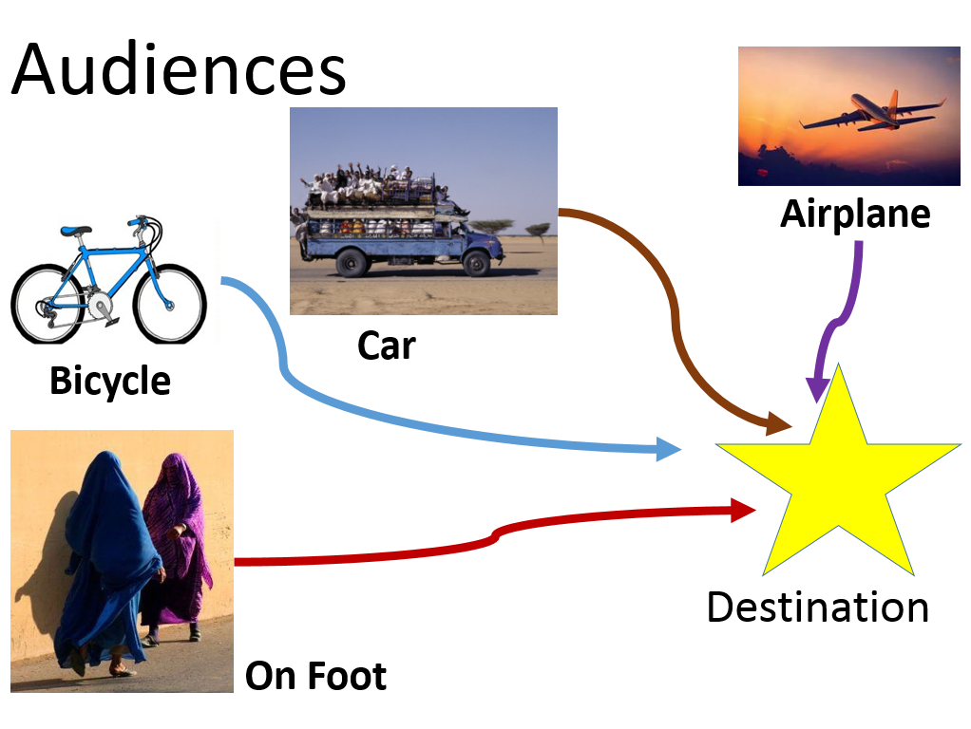
Communication is about translation. In the way that a translator at the UN goes from Arabic to English, I work with information from the extremely detailed and technical to the Twitter post. As long as you have a competent translator, it’s not that either the Arabic or the English is wrong, they are just different. Some people understand one better than the other. But if you speak to someone in a language they don’t understand, you’re never going to get the message across.
I think about communications as a voyage. Ultimately, you want everyone to arrive at the same destination. That’s your key message. And you want all of your complex research and depth to shape what that key message is. At any level and for any audience, you always want to stay true to a core set of messages that you can back up at any depth necessary.
You want people to come to the same place—that’s your message. But there are a lot of different ways to arrive at any one place, and everyone travels a little bit differently. Each audience is going to need a specific set of details and information to get to the same place. So how are people travelling, and what do they need?
In An Airplane
Who: This person might be a donor, a CEO, or an elected official. They don’t have time to get down into the weeds, and don’t always have the training to understand the nuances of every single area of the organization. It might also be the widest part of a lay audience—a customer base, small scale donors, people who could take action on your behalf.
Information needs: Wants the 30,000 foot view. They need the high level messages, and a few brief, key highlights of the work.

Format: These people need the shortest messages possible, and they need to be non-technical and powerful. You have a few seconds to make a big impact. Try photos, infographics, headlines, talking points, or short posts on Facebook or Twitter.
In A Car
Who: This person may be an interested donor, a staffer for a key decision-makers, a non-technical champion, a mid-level manager or a busy technical person.
Information Needs: Wants a little more information to get their feet wet. They need to have a little more depth of understanding, but don’t have time to dive all the way in.
Format: These messages should still be brief, but can contain a few more details. Try 2 page briefs, webpage posting, short blogs or op-eds, infographics with stories attached.
On A Bicycle
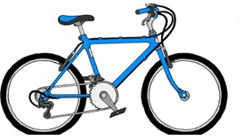
Who: These are people who know about the issue and want to dig in a little more. It might be a technical specialist, an expert from a different sector, or an interested non-expert. They know enough that they need more details for you to catch their attention.
Information Needs: These people are looking to improve their own work and build an expertise. They need enough detail to test assumptions and to adapt for new needs.
Format: Look for formats that have more detail but are highly organized and highlighted. They need good signposting so they can find the pieces that are relevant. Journal articles, deeper reports with good executive summaries, and hyperlinked outlines/briefs are good places to start.

On Foot
Who: These people are already experts, or need to become experts quickly. It might be a technical expert, or a programmer looking to replicate results or understand a project they just picked up.
Information Needs: These people are ready to dive into the deep end. This is the highest level of detail and complexity/nuance in messaging. They need enough detail to be able to implement programs, repeat results, carry out trainings.
Format: You can give these guys everything you have. Full reports, project documentation, they want to see it all.
So how do you make sure that everyone gets to the destination? Make sure that you have a version of your message that will work for everyone. Even if you only want to talk to experts, good headlines and short messages are the first way to attract anyone’s attention. Your short messages should always link to the more complex ones (a Twitter post website short brief full report), so people can get as deep as they want. But you have to cross the beach to go diving, so you should always develop the short, high-level versions of your messaging so you can reach everyone.

