CARE INTERNATIONAL Monitoring, Evaluation and Learning Group

Definitions for counting and reporting participants REACHED and IMPACTED
by CARE projects and initiatives
(July 8, 2019)

Contents
What you find in this document 1
Two recommendations before you define participants reached or impacted 2
1: Be clear on who the impact group and the target groups are 2
2: Be consistent on what participants REACHED and participants IMPACTED means in your context 3
Guidance to define participants REACHED and IMPACTED, based on the modality of implementation your project or initiative has adopted 4
Modality 1: In-kind Assistance 5
Modality 2: Service Delivery 5
Modality 3: Cash Transfers or Vouchers 5
Modality 4: Technical Assistance to other organization 6
Modality 5: Advocacy or influencing 7
Modality 6: Mass media campaigning - Communicating for behavioral change 8
Modality: Other 9

What you find in this document

- Over the years, CARE projects/initiatives have adopted different modalities of implementation for achieving its objectives and contributing to lasting change (e.g. providing in-kind assistance or services to participants; supporting other organizations with technical assistance; advocating/influencing for policy change, etc.). In this document, you find guidance to help you define and report participants REACHED and IMPACTED, for different modalities of implementation.

- This document builds on the efforts from CARE India, Nepal, Timor-Leste, Southern Africa and others, to arrive at definitions of participants that best accommodate to different modalities of implementation, and that best explain the reach and impact of our work. It also takes into consideration the reflections of other peer organizations.

- Through the Project/Program Information and Impact Reporting System (PIIRS), participants data from CARE projects and initiatives around the world is collected every year to describe the REACH of CARE’s work and how CARE contributes to IMPACT/OUTCOMES (e.g. the CARE global map). The application of harmonized definitions for participants reached or impacted is therefore important for ensuring reliable data that can be aggregated globally.

Important:
- If your project or initiative adopts different modalities of implementation simultaneously (e.g. it provides in-kind assistance while also doing advocacy), you will need to combine different options provided in this guidance and arrive at the definition(s) that make most sense for your specific case.

- Every time you report participants REACHED or IMPACTED by your project/initiative, you need to check if there is any overlap with other projects/initiatives and, if so, eliminate any possible double counting/double reporting. Please review the methods recommended for addressing double counting and apply the ones that best fit your case.

Two recommendations before you define participants reached or impacted

1: Be clear on who the impact group and the target groups are

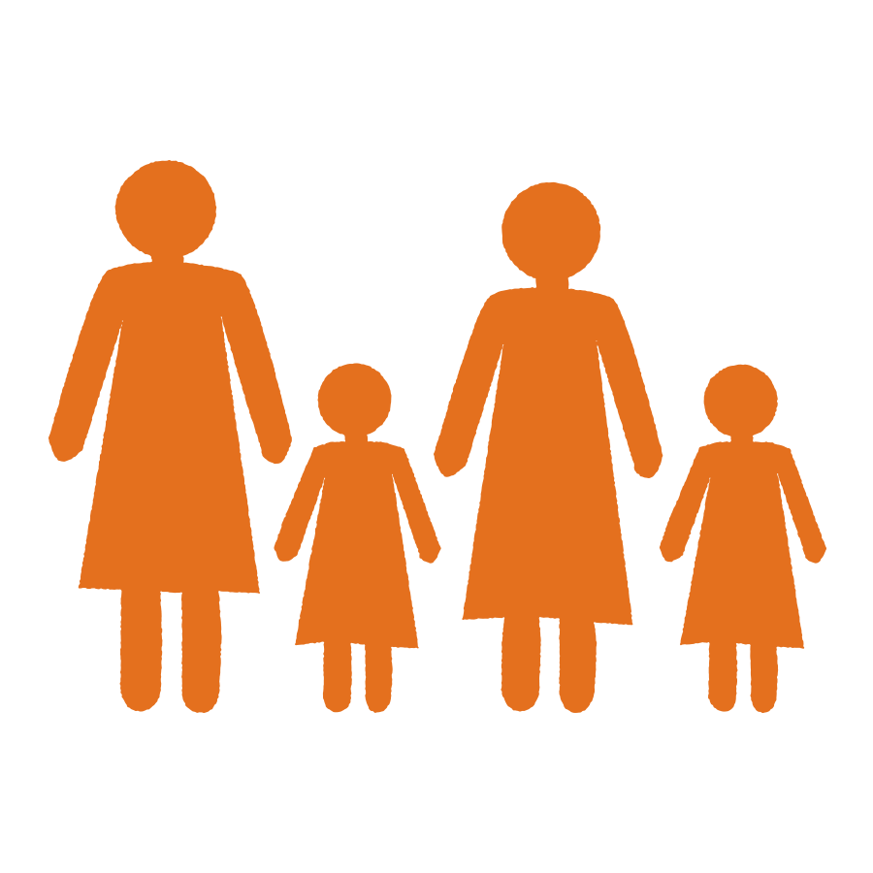
All projects or initiatives have impact and target groups (this may already be in the theory of change or stakeholder analysis). Having clarity on who these groups are is a critical first step for later defining participants REACHED and IMPACTED. At this stage, you don’t yet have to worry about who is a participant reached or impacted (directly or indirectly) and how to report them. You just need you to be clear on who are the people the project or initiative works with/for.
The (various) target groups: Composed of individuals whose actions or behaviors generate outcomes (e.g. changes in attitudes; changes in norms, policies, etc.) that influence the advancement towards lasting change or impacts for the impact group. These are groups with which the project or initiative works towards facilitating change and making a difference for the impact group. Examples: community/religious leaders, civil society representatives, decision makers, government officials, private sector actors, extended family members, community members in general, etc.

The impact group: Composed of a well-defined group of individuals for whom CARE and partners seek to facilitate lasting change or impact. Examples: women and girls; children under 5; poor small farmer households; children in school age; families affected by a disaster or crisis.

Important:
- When looking at impact and target groups in your project/initiative, please remember that they must be identifiable as individuals that can be described and counted. They cannot be identified in general terms like households, families, groups, communities, organizations or other.
- Here some examples of questions that can help you confirm if you are looking at concrete individuals:
  - For the impact group: is the impact group composed of only some individuals from a household? (e.g. mothers and children under 5); or the entire household? (e.g. all individual members of food insecure families); or a clear portion of the population in a given location? (e.g. only women and girls of school age in the area where the project intervenes).
  - For the target groups: who are the individuals that compose the target groups? Is it a clearly defined group of community/religious leaders? Or a specific number of decision makers or government officials? Or a few members of civil society organizations? Or a clear portion of the population in a community? Or all the population in a given location?

2: Be consistent on what participants REACHED and participants IMPACTED means in your context

A participant REACHED is not equal to a participant IMPACTED. Why? because the sole participation of a person in the activities of a project or initiative does not ensure/guarantee that this person will automatically experience lasting change in her or his life.
Participants REACHED  (Output level) | Participants IMPACTED  (Outcome and Impact level)
- Refers to all those individuals that a project/initiative connects with as it implements its activities and delivers outputs.  - Participants REACHED may include  - individuals who are directly involved in activities implemented by the project or initiative, receiving support, services, goods, resources or other, from CARE or partners  - individuals who are not directly involved in activities implemented by the project or initiative, but still indirectly connect with the outputs resulting from those activities.  - Participants REACHED can be classified as DIRECT or INDIRECT participants, however, this classification greatly depends on the modality of implementation that the project/initiative adopts, and other factors. These are described in the next section of this document, including examples. | - Refers to all those individuals who, as a result of the materialization of the goals of a project or initiative, experience lasting change (impact or outcomes).  - Depending on the impact or outcome metrics/indicators your project or initiative uses to measure lasting change, the participants IMPACTED could include:  - Individuals from the impact group, experiencing lasting change in their lives (e.g. households graduating from extreme poverty; families becoming food secure; children under 5 no longer stunted; women generating income and accessing education; women participating in joint decision-making in the household, etc.)  - Individuals from the target groups whose changed behaviors are also part of lasting change (e.g. local leaders/men and boys rejecting intimate partner violence).

Important reminders:
- Participants REACHED are different from participants IMPACTED: Within the definition of participants REACHED, we are just looking at tracking/counting/reporting on individuals that are involved in the activities of a project or initiative. We are not tracking/counting/reporting if/how these individuals are experiencing important changes in their lives (impact or outcomes). For example, a participant that is receiving training would be counted as REACHED and, unless there is an evaluation process to determine if the knowledge acquired in the training has led to a sustained change in practice or behavior, this individual would not yet be counted as participant IMPACTED.
- Related to the point above, in many projects or initiatives, the number of participants REACHED will tend to be larger than the number of participants IMPACTED, however, be aware of possible exceptions! In certain circumstances, the number of participants IMPACTED can be much larger than those directly REACHED, because of the “multiplying effect” of a change facilitated by the project or initiative. For example: A project provided training and services to 3,000 workers who are members of EKATA groups (3,000 direct participants reached) during its implementation. At the end of the project, the evaluation shows that only 2,500 from the 3,000 EKATA members were experiencing changes (outcomes) BUT also showing that 2,000 other workers have gained sustained access to rights via the EKATA actions (the multiplying effect of EKATA groups). As a result, participants REACHED may add to 3,000 but participants IMPACTED add to 4,500 and can be demonstrated with the evaluation.
- The tracking of participants IMPACTED always needs to be supported by an external evaluation process or by a solid (internal) monitoring of outcomes. It also requires the measurement of CARE´s global indicators for measuring change, together with any other indicators that the project or initiative has defined since its design.

With these two initial recommendations addressed, let’s now define participants reached and impacted for your project/initiative!

Guidance to define participants REACHED and IMPACTED, based on the modality of implementation your project or initiative has adopted

Looking at the evolution of CARE’s programming in the past years, we identify the following main modalities of implementation.

Modality 1: In-kind Assistance: CARE (with or without partners) provides assistance in the form of physical goods or commodities to the impact or target populations e.g. food, hygiene kits, non-food items, etc. |  | Modality 2: Service Delivery: CARE (with or without partners) provides services to the impact or target populations e.g. water and sanitation, healthcare, education, protection, legal services, etc. |  | Modality 3: Cash Transfers or Vouchers: CARE (with or without partners) provides assistance in the form of money (either physical currency or e-cash) or vouchers (a paper, token or e-voucher that can be exchanged for a set quantity or value of goods or services)
Modality 4: Technical Assistance to other organization: CARE provides technical assistance to partners or other organizations, for them to provide goods or services to the impact or target populations. |  | Modality 5: Advocacy or influencing: CARE (with or without partners) focuses mainly on advocacy or influencing actions. |  | Modality 6: Mass media campaigning - Communicating for behavioral change: CARE (with or without partners) uses mass media channels or newer social media options for campaigning, sensitizing and engaging different populations.
Modality: Other
There can be exceptional cases where a project/initiative doesn’t really fit within the 6 options described above. These cases that be reported as “other”. See example in the guidance below.

Modality 1: In-kind Assistance

Modality 2: Service Delivery

Modality 3: Cash Transfers or Vouchers

Modality 1: In-kind Assistance: CARE (with or without partners) provides assistance in the form of physical goods or commodities to the impact or target populations e.g. food, hygiene kits, non-food items, etc. |  | Modality 2: Service Delivery: CARE (with or without partners) provides of services to the impact or target populations e.g. water and sanitation, healthcare, education, protection, legal services, etc. |  | Modality 3: Cash Transfers or Vouchers: CARE (with or without partners) provides assistance in the form of money (either physical currency or e-cash or ATM card) or vouchers (a paper, token or e-voucher that can be exchanged for a set quantity or value of goods or services)

General characteristics of these modalities:
- The connection between CARE (whether directly or through our partners) and the participants (target and impact groups) is clear and traceable.
- Most of the data on participants (both reach and impact) comes from primary sources managed by the project or initiative.
- On impact: claiming CARE’s contribution to lasting change (impact or outcomes) is very possible because CARE intervenes in all or most levels of change: inputs-output-outcomes-impact.
Participants REACHED |  | Participants IMPACTED
Direct | Headcount of individuals from both the impact group and target groups, that participate in the activities of the project or initiative and receive, services, goods, resources or other type of assistance. | Contribution to lasting change | For the impact group: Headcount of those individuals from the impact group who evidence experiencing positive change via the measurement of impact/outcome indicators (in an external evaluation or from a solid outcome monitoring system).  Example: 25% of the 10,000 children under 5 in our impact group are no longer stunted (2,500 children)  For the target group(s): (Only if the project/initiative has defined impact/outcome indicators for the target groups) Headcount of those individuals from the target group(s) who evidence experiencing positive change.  Example: 60% of the 50,000 family members of those children under 5 in the impact group, demonstrate improved nutritional practices (30,000 people).
Indirect | Headcount (or estimation) of individuals who do not receive any direct support, services, goods, resources or other from the project or initiative, but are still connected in some way with the activities of the project through their link with the direct participants.  Examples:  - Family members who benefit of a product, service, good or resource that comes from an individual’s engagement in the project’s activities  - Community members who learn something new from the direct participant (e.g. a community leader) involved in the project.
For projects/initiatives implemented in Consortia:
- If CARE is the leader of the Consortia or has a role contributing to the work of all members of the Consortia (e.g. ensures gender integration in the actions of all members of the Consortia), participants reached and impacted can include all those participants reached or impacted by the Consortia as a whole.
- If CARE is a sub-recipient in the Consortia and only responds for a subset of the activities/objectives of the project or initiative, it should only report the participants reached or impacted by CARE’s actions within the Consortia.

Modality 4: Technical Assistance to other organization
Modality 4: Technical Assistance to other organization: CARE provides technical assistance to partners or other organizations, for them to provide goods or services to the impact or target populations.

General characteristics of this modality:
- The connection between CARE (whether directly or through our partners) and the participants (target and impact groups) is not straight forward and complex to trace, given that CARE provides technical assistance to other organizations, for them to connect with participants.
- The data on participants (both reach and impact) may come from primary sources managed by the project or initiative, other secondary sources or census-statistical data.
- On impact: claiming CARE’s contribution to lasting change (impact or outcomes) is only possible with the involvement of the organization(s) receiving technical assistance from CARE, because CARE alone does not intervene in all levels of change: inputs-output-outcomes-impact. Here, it is also important to explain/demonstrate that CARE’s technical assistance was a critical element in the successful implementation of the project or initiative. If so, all the participants tracked by the project or initiative (even if CARE does not connect with the participants directly) can be reported by CARE.
Participants REACHED |  | Participants IMPACTED
Direct | Headcount of individuals from the impact group and target groups that receive support, services, goods, resources or other, from the organization(s) that CARE is providing technical assistance to.  Headcount of staff from the organization that CARE is providing technical assistance to, receiving training or other support. | Contribution to lasting change  (when it can be demonstrated that CARE’s technical assistance is a critical element in the successful implementation of the project or initiative) | For the impact group: Headcount of those individuals from the impact group who evidence experiencing positive change via the measurement of impact/outcome indicators (in an external evaluation or from a solid outcome monitoring system, that can be managed by CARE or the organization(s) receiving technical assistance from CARE).  Example: 60% of the 5,000 women in our impact group are economically empowered (3,000 women).  Note that in this case, CARE may have not implemented activities to support these women but may have provided the necessary technical assistance on Gender/ VSLAs to other organizations, for them to support the women successfully.  For the target group(s): (Only if the project/initiative has defined impact/outcome indicators for the target groups) Headcount of those individuals from the target group(s) who evidence experiencing positive change.  Example: 30% of the 4,000 husbands of the women in the impact group, reject violence in the household (1,200 people).
Indirect | (Only if we can establish a credible count/estimation with the organization(s) that CARE is providing technical assistance to) Headcount (or estimation) of individuals who do not receive any direct support, services, goods, resources or other from the project or initiative, but are still connected in some way with the activities of the project through their link with the direct participants.  Examples:  - Family members who benefit of a product, service, good or resource that comes from an individual’s engagement in the project’s activities  - Community members who learn something new from the direct participant (e.g. a community leader) involved in the project.
For projects/initiatives implemented in Consortia:
- If CARE is the leader of the Consortia or has a role contributing to the work of all members of the Consortia (e.g. provides technical assistance on gender integration in the actions of all members of the Consortia), participants reached and impacted can include all those participants reached or impacted by the Consortia as a whole.
- If CARE is a sub-recipient in the Consortia and only responds for a subset of activities/objectives of the project or initiative, it should only report the participants reached or impacted by CARE’s actions within the Consortia.

Modality 5: Advocacy or influencing
Modality 5: Advocacy or influencing: CARE (with or without partners) focuses mainly on advocacy or influencing actions.

General characteristics of this modality:

IMPORTANT: The definitions in this section apply to initiatives that are EXCLUSIVELY working on advocacy/influencing. If your project or initiative also works in other modalities besides this one, you need to adopt the combination of definitions of participants that best work in your case.

- The connection between CARE (whether directly or through our partners) and the participants (and our ability to count/report on participants) is different for each group of actors:

With the impact groups: the connection is not clear nor straight forward. CARE’s ability to contribute to lasting change for a specific impact group (e.g. women benefiting from a change in inheritance laws) depends on the extent to which the advocacy/influencing initiative materializes in a concrete policy or practice change, which would ultimately change the lives of the impact population.

As a result, claiming CARE’s contribution to lasting change (impact or outcomes) is only possible when the initiative can generate solid evidence on how CARE has played a critical role in achieving a policy/influencing win, and can also quantify the number of people impacted by that policy/influencing win. See below for more details on how to do this.

With the target groups: the connection is clear and straight forward. CARE – via its advocacy or influencing actions – connects with decision makers, policy implementers, community leaders, government representatives, etc. Therefore, the initiative can count/track these participants from primary sources, on a regular basis. Note that calculating/reporting these participants is not mandatory in PIIRS, although may be useful for the initiative’s own monitoring of activities.

Participants REACHED |  | Participants IMPACTED
Direct  or  Indirect | In consultation with advocacy/influencing specialists across CARE, it has been agreed that advocacy or influencing initiatives do not need to report information in PIIRS, on the direct or indirect participants reached through the implementation of advocacy or influencing activities.  NONETHELESS, if the advocacy/influencing initiative implemented activities of mass mobilization or public action such as a march, demonstration or other, there will be a separate category in PIIRS to report an estimation of the people mobilized in those activities (different than people reached). | Contribution to lasting change  (supported with the application of an AIIR tool) | Requires three key pieces of evidence:  - Documented evidence that CARE has played an important role in achieving a policy/influencing “win” - that means – CARE’s advocacy or influencing has contributed to the advancement of a policy or practice that brings or will bring positive change to the impact population (e.g. we can fully demonstrate that CARE played a critical role in the passing of new inheritance law that benefits women in X country)  Note: the “win” can be a final advocacy goal but also an intermediate step towards the final advocacy goal. The application of the AIIR tool is necessary for this analysis.  - Evidence on the number of people that would “potentially” see positive impact in their lives from the policy change (women that would potentially benefit if a new inheritance law is passed). This can be done via census-based estimations or secondary sources.  - Evidence on the number of people that have “actually” benefited from the policy/practice change after the policy is being implemented or the advocacy win has been fully materialized (women that are no longer suffering from the economic violence of disinheritance now that the new inheritance law is being systematically applied)

Modality 6: Mass media campaigning - Communicating for behavioral change
Modality 6: Mass media campaigning - Communicating for behavioral change: CARE (with or without partners) uses mass media channels or newer social media options for campaigning, sensitizing and engaging different populations.

General characteristics of this modality:
- The connection between CARE (whether directly or through our partners) and the participants (target and impact group) is made primarily via mass media channels and products, or social networks. The use of these channels supports the project or initiative´s strategy, engaging different actors towards the achievement of certain outcomes or impact.
- The project or initiative cannot easily establish the connection between inputs-output-outcomes-impact in the context of mass campaigns or social media communication for behavioral change but can track the engagement of different populations with mass media channels, campaign products, or social networks.
- The count of participants is not straight forward and requires some estimations and establishing criteria for determining who the participants are (see below)

- FOR MASS MEDIA CAMPAIGNS SUPPORTING ADVOCACY/INFLUENCING ACTIONS

Participants ENGAGED IN MASS MEDIA campaigns CANNOT be included in REACH |  | Participants IMPACTED
Mass media campaigning coverage (not reach) | Important: Populations reached via mass media campaigns should not be considered within the calculations of DIRECT or INDIRECT categories of participants REACHED (should be counted separately). Why? In most cases, the populations reached via mass media campaigns are engaged with very punctual elements of the project, therefore, their connection with the project or initiative is very different from the rest of actors involved, or from the ultimate impact populations. In PIIRS, there is now a separate section where mass media campaign coverage can be reported.  In all cases, mass media campaign coverage could include a systematic estimation of people engaging with the campaign in all its channels. For instance: web (e.g. signatories of an online campaign, number of shares/likes of a campaign’s material; recipients of radio campaign messaging, etc.) | Contribution to lasting change | If the mass media campaign actions support an advocacy/influencing effort and lead to a policy or practice change, it should be assessed in a similar way to modality 5 above. That means, this would entail the generation of:  - Documented evidence that CARE’s massive campaigning actions have contributed towards the achievement of a policy/influencing “win” - that means – CARE’s campaigning has contributed to motivating citizen action towards advancing a policy or practice that brings positive change to an impact population (e.g. we can demonstrate that CARE’s #ThisIsNotWorking campaign has been critical for actions towards the ratification of the ILO convention).  The application of the AIIR tool is necessary for this analysis.
- FOR COMMUNICATION THAT PROMOTES INDIVIDUAL BEHAVIORAL CHANGE

Participants REACHED |  | Participants IMPACTED
Direct | Headcount of individuals (unique users) engaging with products/messages or materials for awareness raising/ sensitization/call on action in a continued way (the products or materials are part of the project activities). These individuals should be located within the geographic area of the project or initiative.  Examples:  - In social media: unique users engaging with publications, videos, etc. that contain a message towards behavioral change. This can be the count of likes, check-ins, comments, shares or other in a given location.  - TV/Radio: estimation of the individuals that listens to the radio messaging in the geographic area of the project (out of total catchment of media house).  - Household visits: headcount of individuals visited and receiving messages/materials/etc. in the area of intervention of the project or initiative. | Contribution to lasting change | Not easy to determine, unless the project or initiative has the capacity to measure behavioral change in the totality of the population where the project implements its mass media behavioral change actions.  For example: If the communication strategy was focused on reducing gender-based violence, the only way to assess the contribution to positive change would be to implement a representative survey looking at perceptions and actions of the population in relation to GBV and whether the messages/sensitization /information they received from the project’s mass media actions influenced those perceptions or behaviors.  Although potentially very important in terms of impact numbers, demonstrating this contribution to change would involve a very large data collection effort for the project or initiative.
Indirect | (only when relevant) Systematic estimation of people /population outside the geography of the project or initiative, benefiting from the communications for behavioral change provided by the project.

Modality: Other
Modality: Other

There can be exceptional cases where a project/initiative doesn’t really fit within the 6 options above. These cases that be reported as “other” in REACH and may require further substantiation to be reported IMPACT. See example in the guidance below.

Example: A situation in which a national government scales up/replicates/expands a model/tool developed by CARE but in an autonomous way, that means, with no direct engagement from CARE. In this case, CARE has no direct implementation of any programmatic activity, nor it is involved in the government’s use of resources for scaling up, but it has certainly contributed with the model that is being used.

FOR REACH, if CARE has access to reliable data on the reach of the scale up/replication/expansion, it may be possible to report under indirect REACH.

For IMPACT, it would require for the initiative to apply an AIIR tool and generate evidence on how CARE may have influenced the autonomous replication of the model by the Government, and – where possible - estimate the potential/actual numbers of people whose lives are impacted by the replication of that model.

Examples from other organizations: https://www.academia.edu/25034430/Measuring_International_NGO_Agency-Level_Results; Counting beneficiaries - A summary of best practice in the development sector and recommendations for Trócaire; https://prezi.com/krbzqmuhmwut/beneficiary-counting-in-oxfam-guidance/; https://jliflc.com/wp-content/uploads/2014/05/CRS-2.3-Catalogue-Service-and-Beneficiary-Definitions.pdf
Advocacy defined as “the deliberate process of influencing those who make decisions about developing, changing and implementing policies to reduce poverty and achieve social justice.”
Advocacy defined as “the deliberate process of influencing those who make decisions about developing, changing and implementing policies to reduce poverty and achieve social justice.”

