CARE International Monitoring, Evaluation and Learning group
Terms of reference
February 2017

- A general overview of how we collect and report data on CARE’s reach and impact
The consolidation of CI-wide single platform for collecting, accessing and reporting relevant information on the work we do (reach) and what our work is achieving (impact) started with the creation of the Project/Program Information and Impact Reporting System (PIIRS) in 2012, supported by a Steering Committee led CARE Australia, Canada, Nederland, UK, USA and the CI Secretariat.

Ever since, CARE International has undertaken a series of initiatives aiming at strengthening a culture of interconnected information, knowledge management, improved MEL practice and better ways to inform and share our work with external stakeholders. The CI Secretariat has taken a strong role coordinating these actions, and the achievements have been possible with the contribution of colleagues in CARE offices around the world.

Examples of achievements in the past four years include:

  - Four years of data collected on the characteristics and reach of projects and programs around the world. This data is accessible to all CARE staff though the web-based PIIRS platform, and used for many internal and external purposes.
  - Collaboration with initiatives in different CARE offices, aiming at improving MEL practices and/or using innovative ways to analyze and visualize data.
  - Yearly impact reports produced, featuring evidence of achievements and learning around the outcomes of the CARE2020 Program Strategy.
  - A summary approach for global MEL produced, based on an extensive review of impact assessment approaches inside and outside CARE.
  - The development of the impact indicators for the CARE2020 Program Strategy and the future collection of impact data from projects and programs around the world.

- The CI MEL group – purpose, accountability and membership
The CI MEL group acts as a reference team to further advance improve and expand an interdependent MEL agenda for all CARE, and to facilitate learning and capacity building for a broader MEL network, including MEL and programs staff around the world.

The group is commissioned by the CI Program Team and accountable to both the CI Program Team and the Program Quality and Impact Strategic Leadership Team. The overall coordination of the group is made by the CI Programs Director and the PIIRS Manager.

The group is composed of CARE staff who lead or are highly involved in the development and management of sector or outcome specific MEL systems and can consolidate a global MEL capacity for monitoring, reporting and leaning around the outcomes and approach of the CARE2020 Program Strategy.

Initial members include:

- Humanitarian Assistance: Uwe Korus (CEG – CI Secretariat)
- Sexual, Reproductive and Maternal Health and Rights: Dora Curry (SRMH – USA)
- The Right to a Life Free from Violence: tbd
- Food and Nutrition Security & Climate Change Resilience: Emily Janoch / Pierre Kadet (FNS USA-Canada)
- Women's Economic Empowerment: Regine Skarubowiz (WEE- UK)
- Gender Equality: Sarah Eckhoff (Gender – USA)
- Governance: Tom Aston (Governance – UK)
- Resilience: Mirjam Locadia (Resilience – NL)
- Advocacy: Amanda Mathies and Rasha Natour (Advocacy - CARE USA)
- General MEL: George Kurian (India), Kaia Ambrose (Canada), Santiago Nunez-Regueiro (France), Maria Christophersen (Norway), Malaika Cheney-Coker (USA), Korinne Chiu (USA), Neil Poetschka (Australia), Nicola Giordano (UK), Sofia Sprechmann (CI Secretariat), Ximena Echeverria (CI Secretariat), Jay Goulden (CI Secretariat), Claudia Sanchez (LAC), Gideon Cohen (Southern Africa), Retta Lossane (CI Secretariat)

Note: Colleagues from other CARE teams and offices will be invited to the CI MEL group, once the different priorities for the team are rolled out.
- The CI MEL group – asks and priorities
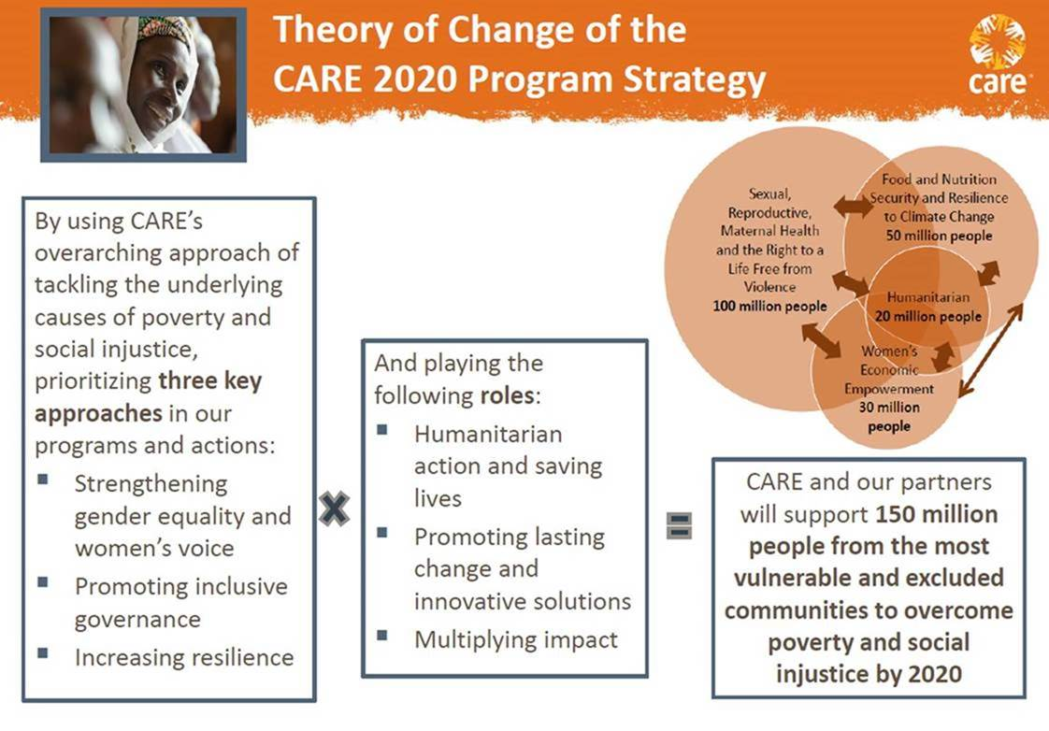
In line with the commitments stablished in the CARE2020 Program Strategy and the organizational drive to improve MEL practice, The MEL group will focus in responding to two main asks:
- Assess and report on WHAT changes are taking place as a result of our work: This implies the definition of robust and systematic means for measuring outcomes and impact, using the global indicators and sub-indicators. (e.g. being able to systematically track and report on the changes in % of people with moderate or severe food insecurity in areas where CARE implements FNS-related actions)
- Demonstrate HOW we CONTRIBUTE to lasting change, as we address the underlying causes of poverty and social injustice: this implies the definition of methods that allow CARE to confidently demonstrate that its actions are a critical driver to achieving lasting change. (e.g. demonstrating that CARE FNS actions are critical for the reduction in % of people with moderate or severe food insecurity; strengthening our capacity to explain and test the theories of change behind our work.)
Based on the above described asks, the work of the MEL group will focus on the 9 priorities listed below, including examples of work already being done in each of them (in orange). These 9 priorities will be the pillars of CARE’s global MEL agenda and, in most cases, build on important work already started by members of the MEL group or other teams around the world.

Assess WHAT changes are taking place | Demonstrate HOW we CONTRIBUTE to change
- “Unpacking” indicators and developing more robust guidance - concepts, definitions, calculation methods, survey questions, learning questions, etc. (2 pagers, FNS sub-indicators guidance, dialogue: relationship between Governance and Resilience indicators / CARE’s Humanitarian and OFDA indicators, etc.)  - Capacity building on the indicators - training and answering questions from CARE offices around the world (Bangladesh questions, FAQs, FNS future training while piloting sub-indicators)  - Deeper analysis for reporting impact and reach data - analysis of PIIRS data, defining methods/calculation protocols to aggregate impact data (LAC and Southern Africa IM systems) | - Update CARE’s global approach to MEL under the premise that CARE “contributes to change” (The Route to CARE’s global MEL)  - Capacity building on the most appropriate combination of methods to demonstrate how we contribute to change (Contribution Tracing, Outcome Mapping, Most Significant Change)  - Update MEL standards/minimum requirements based on the “contribution to change” logic (The Evaluation policy, Evaluation Library, Standards developed by Australia, UK, others)
Report and learn from our evidence
4. Better ways visualize data and learn from it (Impact Mapper, World of Impact, future SharePoint)

5. Impact reports (LAC, Asia Reports, GBV, SRMH, GiE, and future reports: global, WEE, FNS&CC, etc.)

6. Inform all of CARE - Report to Program Team/PQ SLT: MEL Updates

- The CI MEL group – responsibilities

Based on their expertise, role and the work they are doing in different CARE offices, members of the CI MEL group will lead or contribute to the different priorities of the MEL group. By committing to taking on a task, Members of the group will most likely work on something that is already part of their day-to-day work, however, these are the changes expected:
- Members will dedicate at least 25% of their time to actions strongly connected to the CI MEL group.
- Members will be working on MEL issues on behalf of all of CI – and thereby influencing all of CARE.
- Members will be constantly connecting to other teams around the world, ensuring greater inclusion, consultation and learning.
- Members will be active participants in meetings of the CI MEL group held every two months, and occasional one-off calls. Note that the majority of interactions will occur virtually, though it is anticipated that face-to-face gatherings may be required once a year.
An indicative summary of actions, responsibilities and deliverables, includes:

 | Priority | Leads | Collaborates | Examples of deliverables
Assess WHAT changes are taking place | - Unpacking” indicators and developing more robust guidance - concepts, definitions, calculation methods, survey questions, learning questions, etc. (2 pagers, FNS sub-indicators guidance, dialogue and FAQs: relationship between Governance and Resilience indicators / CARE’s Humanitarian and OFDA indicators, etc.) | Outcome and approach leads: Dora, Pierre, Uwe, Regine, Sarah, Tom, Mirjam  Jay and Ximena | All group members | MEL guidance documents, FAQs.
 | - Capacity building on the indicators - training and answering questions from CARE offices around the world (Bangladesh questions, FAQs, FNS future training while piloting sub-indicators) | Outcome and approach leads: Dora, Pierre, Uwe, Regine, Sarah, Tom, Mirjam  Jay and Ximena |  | FAQs, WebEx’s, stablishing calendars tor Q&A sessions (e.g. “Governance indicators Mondays”)
 | - Deeper analysis for reporting impact and reach data - analysis of FY16 PIIRS data, defining methods/calculation protocols to aggregate impact data (LAC and Southern Africa IM systems) | Outcome and approach leads: Dora, Pierre, Uwe, Regine, Sarah, Tom, Mirjam  Jay and Ximena | Outcome and approach leads: Dora, Pierre, Uwe, Regine, Sarah, Tom, Mirjam | FY data base  FY data reports: country, regions, outcomes, approach, CI member  Protocols for data aggregation.
Demonstrate HOW we CONTRIBUTE to change | - Update CARE’s global approach to MEL under the premise that CARE “contributes to change” (The Route to CARE’s global MEL) | Ximena | Nicola, Neil | Updated 5-pager on CARE's approach to MEL
 | - Capacity building on the most appropriate combination of methods to demonstrate how we contribute to change (Contribution Tracing, Outcome Mapping, Most Significant Change) | Tom, Kaia, Claudia | Ximena, Malaika, Korinne | Compilation of most appropriate methods  Training events
 | - Update MEL standards/minimum requirements based on the “contribution to change” logic (The Evaluation policy, Evaluation Library, Standards developed by Australia, UK, others) | Nicola, Neil | Ximena, Kaia, Korinne, Malaika | Updated version of the MEL Evaluation Policy and Summary MEL standards
Report and learn from our evidence | - Better ways visualize data and learn from it (Impact Mapper, World of Impact, future SharePoint) | Ximena, Malaika | Malaika | A set of validated alternatives of KM or data visualization platforms that best fit CARE’s needs
 | - Impact reports (LAC, Asia Reports, GBV, SRMH, GiE, and future reports on WEE, FNS&CC, etc.) | Sofia and Dora: SRMH  Sofia and Regine: WEE | Jay | Impact Reports
 | - Inform all of CARE - Report to Program Team/PQ SLT: MEL Updates | Ximena and Sofia | All members | MEL update

The PQI SLT is responsible for providing strategic leadership for enhancing CARE’s interdependent work for increasing the relevance, quality and impact of programs, with the aim of using learning, knowledge and advocacy for multiplying impact.

